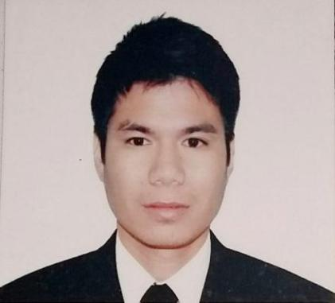
RONALD AVILES
ADDRESS: LABRADOR, PANGASINAN, PHILIPPINES
PHONE NUMBER: 0967-960-6198
EMAIL ADD: avilesronald399@gmail.com

CAREER SUMMARY

Highly experience Automotive Mechanic / Technician with 8 years of experience a record of excellence and passion for delivering quality service in diagnostic, maintenance and repair of vehicles. Skilled in diagnosing engine, troubleshooting and mechanical repair a variety issues using advanced equipment tools all make and of vehicles.

SKILLS

• Troubleshooting • Mechanical Repair
• Engine Overhaul • Tune-up
• General Oil Routine Maintenance • Vehicle Diagnostic
• Wheel Alignment Manual • Engine Replacement

WORK EXPERIENCE

AUTOMOTIVE MECHANIC / TECHNICIAN
Munif Al-Nahdi Trading Group Mize - Jeddah, Saudi Arabia
July 11, 2013 - July 12, 2022
Multi - Brand Car : Toyota, GMC, BMW, KIA, Honda, Hyundai, Ford, Chevrolet, Cadillac, Dodge, Lexus, Nissan

- Proficient in using scanner program to diagnose and repair vehicles.
- Diagnosis and repair to ability to take down the whole engine to replace everything the spark plugs, malfunction sensors and leak in the oil seals including overhauling to replace all bearings, rings and resurfacing head cylinder and grinding valve seats.
- Repairing and replacing worn and defective parts and reassembling mechanical components referring to service manual as needed.
- Inspecting vehicle engine and electrical components to diagnose issues accurately.
- Performing routine maintenance to change engine oil, transmission fluid, brake and clutch fluid, differential oil and others.
- Repair vehicle automotive system including the engine, suspension, brake system, underchassis, differential and transmission.
- Able to learn new automotive technology repair and service procedure and specification.

AUTOMOTIVE MECHANIC / TECHNICIAN
Saudi Services Electro Mechanic SSEM - Riyadh, Saudi Arabia
February 23, 2013 - March 9, 2016
Multi - Brand Car : Hyundai, Toyota, BMW, GMC, Nissan, Ford, Mitsubishi

- Conduct inspection and testing of vehicle system and components.
- Replaced worn or malfunction parts including MAF sensor, spark plugs, ignition coil, catalytic converter, fuel injector, MAP sensor, oxygen sensor and others.
- Perform tune ups, steering system and others preventative maintenance on cars and trucks.
- Inspecting removing and repairing muffler mountings and fitting new muffler, extractors and exhaust pipes.
- Perform work according to policies and procedures and maintains a clean and safe working environment.
- Verifies vehicle service ability by conducting test drivers, adjusting control and system.
- Tested equipment for faults, like broken or cracked hoses, belts, inoperative lights and worn battery.

EDUCATION

Diploma in Automotive Servicing NC II
Lingayen Technological Institute (LTI)
Vocational 2008 - 2010

Diploma in Electronic Technology
Pangasinan School of Arts and Trades (PSAT TESDA)
Vocational 2006 - 2007

