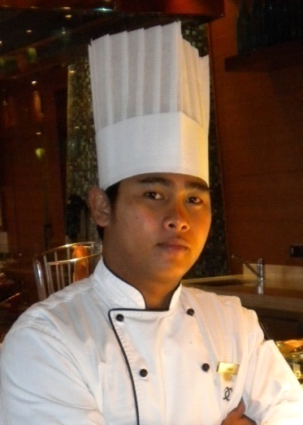
WILKEN NICOR SIACOR
Lot 22 Blk 4 Phase 4 Salangsang Village
San Isidro, General Santos City Philippines
Mobile No. +63 9813983337/+639461103204
Whatsapp No. +63 9813983337
Email add: wilken_1959@yahoo.com
Skype: Wilken_1959

OBJECTIVE:
To assist in creating optimum customer satisfaction by providing
the highest standard of food quality and presentation according
to the hotel procedures and standards.

Seeking FOR the Position of CHEF DE PARTIE.

SUMMARY OF QUALIFICATIONS:

- Exceptional ability to speak, read, write and understand the English language, being used in the workplace.
- Profound ability to read and write in order to facilitate the communication process.
- Strong ability to work in extreme temperatures.
- Exceptional ability to stand and exert well-paced mobility for up to 4 hours in length.
- Great pace and ability to reach other departments of the hotel on a timely basis.
- Knowledgeable of different kinds of cooking method, dressings and cooking terms.

PERSONAL INFORMATION:

AGE : 40 years old
DATE OF BIRTH : August 14, 1982
PLACE OF BIRTH : Libungan, North Cotabato, Philippines
NATIONALITY : Filipino
CIVIL STATUS : Married

EMPLOYMENT RECORD:

Chef de Partie 09 September 2022 to Present
OCEANIA MARINA
INTERNATIONAL CRUISE SERVICES, SDAD, LTDA

Asst. Chef de Partie (SUSHI IN CHARGE) 17 October 2017 to 08 September 2022
OCEANIA MARINA
INTERNATIONAL CRUISE SERVICES, SDAD, LTDA

JUNIOR SOUS CHEF 14 Nov 2014 to 04 Sept 2017
SOFITEL BAHRAIN ZALLAQ THALASSA SEA AND SPA

CHEF DE PARTIE 17 Apr 2013 to 10 Nov 2014
H.H. THE EMIR's DAFNA PALACE
Doha, Qatar

CHEF DE PARTIE 17 Feb 2011 to 12 April 2013
SOFITEL BAHRAIN ZALLAQ THALASSA SEA AND SPA

DEMI CHEF DE PARTIE 01 Jan 2008 to 14 Feb 2011
AL AREEN PALACE AND SPA (Formerly Banyan Tree Al Areen)

STEWARD (PRE-OPENING) 16 Dec 2006 to 31 Dec 2007
Banyan Tree Desert Spa and Resort AL AREEN

ACHIEVEMENTS:

Ambassador of the Month
Month of March 2012
sOFITEL BAHRAIN ZALLAQ THALASSA SEA AND SPA
105 Zallaq Highway, Building 2015
Block 1055, Zallaq Area
P.O. Box 5554 Manama
Kingdom of Bahrain

Nominee Ambassador of the Year
for the Year 2012
sOFITEL BAHRAIN ZALLAQ THALASSA SEA AND SPA
105 Zallaq Highway, Building 2015
Block 1055, Zallaq Area
P.O. Box 5554 Manama
Kingdom of Bahrain

Ambassador of the Month
Month of December 2015
sOFITEL BAHRAIN ZALLAQ THALASSA SEA AND SPA
105 Zallaq Highway, Building 2015
Block 1055, Zallaq Area
P.O. Box 5554 Manama
Kingdom of Bahrain

Ambassador of the Year
Year 2015
sOFITEL BAHRAIN ZALLAQ THALASSA SEA AND SPA
105 Zallaq Highway, Building 2015
Block 1055, Zallaq Area
P.O. Box 5554 Manama
Kingdom of Bahrain

EDUCATIONAL BACKGROUND

Technical Education and Skills Development Authority
NC3 – Ships’ Catering (Ships’ Cooks)
14 July 2022-13 July 2027

SKILLS:
Fruit and Vegetable carvings
Reasonable English Language skills
Handles demanding workload
Sound knowledgeable of working practices of the kitchen

