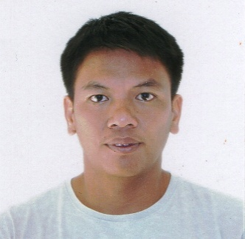
Resume Of
RYAN REYES y PASTORES
286 Sn. Francisco St., Paltao, Pulilan, Bulacan
+966 594583594
reyesryan1220@gmail.com

Qualifications Summary
Truck Driver adept at navigation and efficient, on-time deliveries. Personable and energetic. Dependable and committed to getting each job done quickly, efficiently, and safely, over eight years experience in a distribution environment.

Personal Skills and Competencies:
- Carries a positive mind-set towards my job, my co-employees and towards the employer I work with.
- Upholds high standards for quality performance, professionalism and active sense of responsibility.
- Able to work under extreme pressure.
- With excellent analytical and problem solving skills.
- Able to perform multitasking while still maintaining focus on each of the task handled.

Personal Information:

Date of Birth: December 20, 1981
Place of Birth: Muntinlupa City
Civil Status: Married
Religion: Roman Catholic
Height: 5’6”
Nationality: Filipino
Language Spoken: Filipino, English

Educational Background:

College:
2000 – 2002 Baliuag University
(Bachelor of Science in Secondary Education)
Baliuag, Bulacan
Undergraduate

1999 – 2000 Bulacan State University
( Bachelor of Science in Electronics and Communication Engineering)
Malolos, Bulacan
Undergraduate
High School:

1994 – 1998 Guiguinto National Vocational High School
Guiguinto, Bulacan

Elementary:

1988 – 1994 Pulilan Central School
Pulilan, Bulacan

Work Experiences:
Position Trailer Driver
2015 – Present M. Sh. Al-Zafer Trading Est
Dammam, Kingdom of Saudi Arabia

Position Executive Driver
2013 - 2015 Delta Earthmoving Inc
Didipio/OGPI project
Kasibu, Nueva Vizcaya
Duties and Responsibilities: To safely travel my passengers on time in their point of direction.

Position Trailer Truck Driver
2010 – 2012 CJ ALCONS
Alfonso Lista, Ifugao
Duties and Responsibilities: To travel safely, and deliver products in time and in good condition.

Position Light Truck Driver
2009 – 2010 Tijujaka Enterprices
Pulilan, Bulacan
Duties and Responsibilities: To deliver goods in time and in good condition.

Position Driver
2005 – 2008 Ladino Transport
Tandang Sora, Quezon City
Duties and Responsibilities: Deliver artist/ talents to shooting location on time while keeping the passengers safe
upon arrival.

Position Machine Operator
2003 - 2004 Alphatec Development Corporation
Balagtas, Bulacan

Character References:

Mr. Julian Lalata Proprietor, Tijujaka Ent.
0922-811-4887

Mr. Czaldy Alindayo Proprietor, CJ ALCONS
0999-991-9550

Mr. Melvin Escalante HR Manager
Didipio/OGPI Project
0917-578-3484
Mr. Ibrahim Transport Brach Mngr.
Dammam KSA
+966554798555

I hereby certify that the above information is true to my belief.

RYAN P. REYES
Applicant

