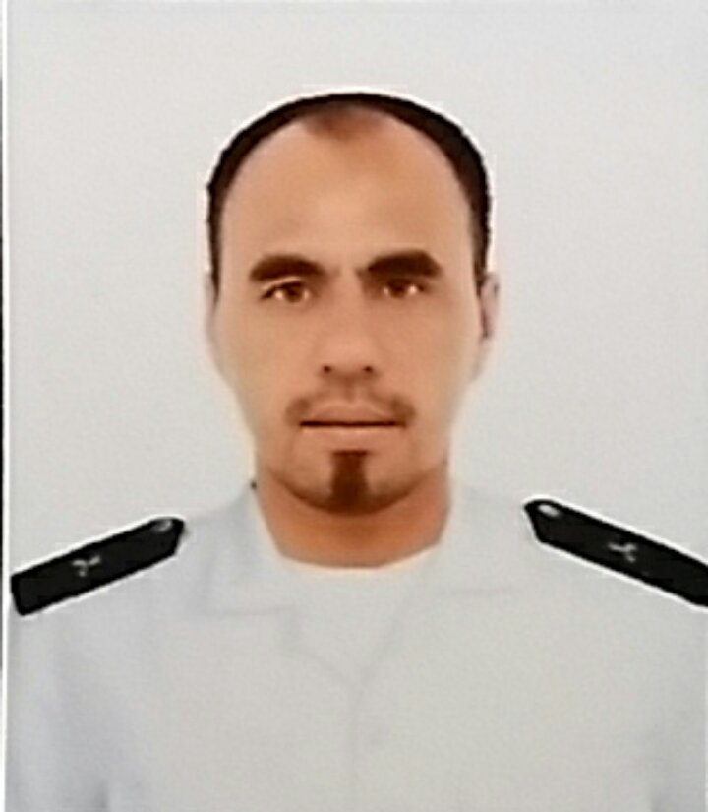

Photo

Full Name: MILTON L. MOTOL
Position : OUTBOARD MECHANIC
Address : ZONE 2 SOCORRO ORIENTAL MINDORO PHILS.

PROFILE SUMMARY

- Total years of experience and total years in abroad/17 YEARS AT SERVICE
- Expertise in – MAIN ENGINE AUXILIARY ENGINE/OUTBOARD AND INBOARD ENGINES
- Repairs and Troubleshooting performed – RECTIFYING FUEL SANCTION AND CONDITION
- Diagnostic Tools used – DEFLECTION GAUGE, PRECISIONS TOOLS, SPECIAL TOOLS, COMPUTER DIAGNOSTIC SYSTEM
- Strength – OVERHAULING ENGINES AND TROUBLE SHOOTING
- Weakness – REPLACING EXHAUST MANIFOLD AND ASBESTOS MATERIALS
- On a daily basis
  - how many minor repairs can you finish? 10-15
  - how many major repairs can you finish? 3-8

PROFESSIONAL EXPERIENCE (All employment from Present up to First Employment)

Date : MARCH 2014 UP TO PRESENT
Position : ENGINE MECHANIC
Company Name : HOLLAND AMERICA LINE INC.
Location : 450 3RD AVE. WEST SEATTLE, WA 98119
Department : ENGINE DEPARTMENT
Reason for leaving : TO GAIN MORE EXPERIENCE AND HIGHER SALARY

Company Profile/Description: PASSENGER CRUISESHIP LINES

Duties and Responsibilities
- GENERAL MAINTENANCE OF OUTBOARD ENGINES D’ TORQUE (YANMAR) 115HP ONBOARD AMERICAN LINE VESSELS
- GENERAL MAINTENANCE OF INBOARD SERVICE BOATS ENGINES YANMAR, IVECO AIPO, VOLVO, STYRE ENGINES
- PREVENTIVE MAINTENANCE AND OVERHAULING OF WARTSILA ZAV40S AND ZAL8S
- ASSISTING FUEL AND LUBRICATING OIL, PURIFIER ALFA LAVAL
- MAINTENANCE AND OVERHAULING OF CUMMINS AND ISOTTA FRANCHINI, EMERGENCY GENERATORS ONBOARD HOLLAND AMERICA LINE VESSEL
Troubleshooting/Repairs performed:
- OVERHAULING OF TURBO CHARGER VTR354/VTR454
- CALIBRATING OF FUEL INJECTORS
- CALIBRATING AND TIMING OF FUEL PUMPS
- DEFLECTION OF CRANK SHAFT
- TAPPET CLEARANCE AND REPAIR THE DAMAGED PARTS OF THE ENGINES

Scan/Diagnostic Tools used:
- DEFLECTION GAUGE
- PEAK PRESSURE KISTLER
- THERMAL IMAGING CAMERA
- FORSCAN

Date : MARCH 2011 TO DECEMBER 2012
Position : MARINE MECHANIC

Company Name : AL FARDAN MARINE
Location : DOHA QATAR
Department : MARINE DEPARTMENT
Reason for leaving : APPLYING FOR CRUISE SHIP INDUSTRY
Company Profile/Description: MARINE SUPPLY AND SAILING YACHT AND MARINE ENGINES
Duties and Responsibilities
- REPAIR OF BOATS AND MAINTENANCE
- MAINTANING THE HIGHEST STANDARD OF REPAIR AND QUALITY OF THE MANUFACTURER
- OVERHAULING OF MERCURY, MERCRUISER, VOLVO PENTA, DETROIT, AND MAN DIESEL
- MAINTENANCE SUPER YATCH ENGINES OF RIVA, DOMINATOR MAJESTY AND GENERAL YACHT
- PLANNED MAINTENANCE AND WORN OUT PARTS
- Troubleshooting/Repairs performed:
- WIRING AND TROUBLE SHOOTING AND REPAIR OF REPLACING THE NEW PARTS
- CHANGING FUEL FILTERS AND LUBE OIL FILTERS
- REPLACING SPARK PLUGS
- CHECKING FUEL PUMPS
- CHECKING STARTER AND ALTERNATOR

Scan/Diagnostic Tools used:
- COMPRESSION TESTING TOOLS
- ELECTRONIC COMPUTER MANAGEMENT
- CALIBRATING TOOLS AND DIAGNOSTIC DEVICE

Date : JUNE 2002-NOVEMBER 2005 Position : SERVICE CREW
Company Name : AL HOKAIR LAND
KINGDOM OF SAUDI ARABIA
Location : A&W RESTAURATNT AND PERKY’S PIZZA
Department : RESTAURANT DIVISION
Duties and Responsibilities
- TAKING FOOD AND DRINKS ORDERS FOR COSTUMERS WITH ACCURACY,
- PREPARING ORDERS
- SERVING COSTUMER
- CLEAN AND ARRANGE DINE-IN AREA AND KITCHEN SPACES

Date : OCTOBER 2005-JANUARY 2007
Position : DELIVERY DRIVER
Company Name : KFC BAHRAIN
Location :BAHRAIN AND KUWAIT REST. CO. W.L.L.
MANAMA, KINGDOM OF BAHRAIN
Department : AMERICANA RESTAURANT DIVISION

Duties and Responsibilities
- LOADING, TRANSPORTING AND DELIVERING ITEMS IN SAFE TIMELY MANNER
- ACCEPTING PAYMENT PER DELIVERY ITEMS
- PROVING EXCELLENT COSTUMERS SERVICE

Date : DECEMEBER 1999-MAY 2000
Position : SERVICE CREW
Company Name : JOLLIBEE PHILIPPINES
Location : SM, BACOOR L3
Department : JOLLIBEE FOOD CORPORATION PHILIPPINES
Duties and Responsibilities
- TO ENSURE THAT COSTUMERS ALWAYS HAVE A GREAT TIME WHEN DINING AT THE RESTAURANT
- PREPARING FOR ALL EQUIPMENTS AND SANITIZED
- SERVING FOOD AND QUALITY STANDARD

TRAININGS AND SHORT COURSES

Course : AUXIALIARY MACHINERY ALFA LAVAL, BOILER OPERATION MAINTENANCE SYSTEM
Training Center : GIGA MARE INC.
Location : SUBIC BAY FREEPORT ZONE PHILS.
Date : SEPTEMBER 21, 2015 TO OCTOBER 02, 2015

Course : ENGINE MECHANIC/TURBO CHARGER
Training Center : GIGA MARE INC.
Location : SUBIC BAY FREEPORT ZONE PHILS.
Date : OCTOBER 05, 2015 TO OCTOBER 13, 2015 Course : 4 STROKE MEDIUM SPEED DIESEL ENGINE AND TURBO CHARGER Training Center : GIGA MARE INC.
Location : SUBIC BAY FREEPORT ZONE PHILS.
Date : FEBRUARY 27, 2017 TO MARCH 07, 2017
Course : PROFICIENCY IN SURVIVAL CRAFT AND RESCUE BOATS
Training Center : CONSILIDATED TRAINING SYSTEM INCORPORATED
Location : 4TH FLOOR S&L BLDG. 1500 ROXAS BLVD. ERMITA MANILA PHILS.
Date : JULY 11, 2016 TO JULY 14, 2016

EDUCATIONAL BACKGROUND

Inclusive Date : June 1999 to October 1999
Course : Basic Seaman Courses
College School : Philippine Merchant Marine School
Location : Las Pinas, Philippines

Inclusive Date : June 1996 to March 1997
High School : Eastern Mindoro Institute of Technology and Science
Location : Pinamalayan, Oriental Mindoro Philippines

PRSONAL DATA
Full Name (First, Middle, Last) : MILTON L. MOTOL
Nickname : MILTON
Date of Birth : MARCH 9, 1978
Place of Birth : PINAMALAYAN, ORIENTAL MINDORO, PHILIPPINES
Height : 163 CENTIMETER
Weight : 63 KG.
Religion : ROMAN CATHOLIC
Languages Spoken : ENGLISH, TAGALOG
Citizenship : FILIPINO
Marital Status : MARRIED
Cell Number : +63 9065080519
Email : milan_gayle@yahoo.com
Facebook Name/Email : MILTON L. MOTOL/milan_gayle@yahoo.com
Passport Number : P7671514B
Expiry Date : 22 SEP 2031

Address
Current : ZONE 2 SOCORRO ORIENTAL MINDORO PHILS.
Home : REMERCO SUBDIVISION, ZONE 2 PINAMALAYAN
Provincial : ORIENTAL MINDORO, PHILS.

In case of Emergency
Contact Name : MITCHELL V. MOTOL
Relationship : WIFE Contact No. : +63 9076463239

