JERRY E. CRISTOBAL
Permanent Address: Blk 22 Lot 2, Leoncia Village Paxton St Santo Domingo, Angeles City, Pampanga, Central Luzon, 2009
Email: jela4ever@yahoo.com
Mobile No. : 0919 881 5129/0969 472 8436
Position applying for: Welder/Fabrication
Preferred job site: Canada

CAREER OBJECTIVES:

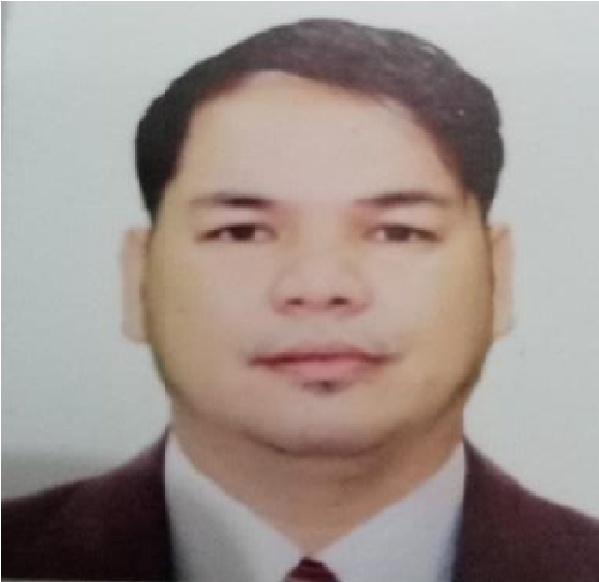
To be employed in a capital organization wherein my skills and capabilities will help me to further develop and enhance my skills and, at the same time, grow together with the company. This will enable me to use my experience to work and cooperate well with others. I am dedicated to giving the best quality to customers using my experience and knowledge.
SUMMARY OF QUALIFICATION:
- Knowledge in SMAW and GMAW.
- Metal craft/truck parts welding.
- Worked at Troycor Lightning Corporation as a fabricator/welder for 2 years and 5 months.
- Worked at QSJ Motors Phils Inc. as a welder for 4 years and 9 months.
- National Certificate 1&2 for SMAW
- National Certificate 2 GMAW

SKILLS:
- Driving of car, truck, and motor
- Operation of machine/Bending machine/Cutting machine
- Communication
- Work well under pressure
- Plumbing
- Forklift operator
- Overhead crane operator
- Know how to use oxy acetylene and plasma cutting.
- Hardworking, willing to handle responsibilities.
- Self-motivated and hard-working person.
- Knowledge in using Tungsten Inert Gas (TIG) welding process
- Knowledge in welding alignment

PROPESSIONAL EXPERIENCES:
Company: Troycor Lightning Corporation, Clark, Pampanga, Philippines
Nature: Manufacturer of high-end lighting fixtures/chandeliers.
Position: Welder/Fabrication
Inclusive Date: Jan 28, 2020 - July 22, 2022
Work Hours 8 Hours
Workday Monday to Saturday - 6days
Monthly Salary PHP 12,840

Job description:
- Welding
- Drilling
- Grinding
- Fabricate
- Using acetylene

Company: QSJ Motors Phil’s Inc., Angeles City, Pampanga, Philippines
Nature: Truck Dealer
Position: Welder (SMAW/GMAW)
Inclusive Date: September 9, 2013- June 17, 2018
Work Hours: 8 Hours
Workday Monday to Saturday – 6 days
Monthly Salary PHP 8,856

Job description:
- Welding truck parts, putting, and connecting it together
- Perform inspections on materials such as flooring, sidings, and headboards upon arrival.
- Determines and reports any repairs or issues with the Intermodal container to the Barge Maintenance Supervisor
- Repairs may include such things as:
-Inserts siding of truck
-Crack repairs
-Bending and fabricating of metal to repair certain areas
- Patches of cracks/holes that can’t be welded appropriately
- Cover repair (usually fiberglass patching and repair)
- Responsible for the care of the welding machines and any company owned equipment that is used during the repair process
- Reports all issues (equipment, crew, working conditions) that may impact the repair process in a negative fashion
  - Must be able to work in confined spaces
  - Must be able to use a respirator
- Performs other duties assigned by Barge Maintenance Supervisor (when applicable), Operations Manager, or General Manager

EDUCATIONAL BACKGROUND:
College Education: AMA Computer College
Angeles City, Pampanga
Computer Programmer- Undergraduate
Secondary Education: Pampanga High School
San Fernando, Pampanga, Philippines
1995-1999
Elementary Education: Mababang Paaralan ng Sta. Cruz
Porac, Pampanga, Philippines
1988-1995

SEMINARS ATTENDED:
Shielded Metal Arc Welding NC 1 & 2 (SMAW NC 1 & 2)
July 9, 2012- September 28, 2012
Provincial Manpower Training Center (TESTA) San Fernando Pampanga

Gas Metal Arc Welding NC 2 (GMAW NC 2)
JCE Training Center, Balibago, Angeles City
(Attend Assessment Only)

PERSONAL DATA:
Passport Number  Passport Validity  Age: | P8020803A  20 July 2028  41 years old
Date of Birth: | July 13, 1981
Place of Birth: | Porac, Pampanga, Philippines
Gender: | Male
Nationality: | Filipino
Civil Status: | Married
Religion: | Roman Catholic
Skills: | Computer Literate
Language Spoken:  Name and Age of Wife  # Of Children  Name  Language | English, Tagalog, and Basic Arabic  Laarni R. Cristobal  43 years old  December 16, 1979  2 Male  Hart Nicole R. Cristobal  20 Years old  Jian Angelo R. Cristobal  16 Years old  Tagalog, English, and Kapampangan

PROFESSIONAL REFERENCES:
Mr. Ronnie L. Sellote
Manager/ Professional Teacher
Yummy Fork Restaurant
+966544569258
Former Co-worker

Mrs. Susan Gonzales
Police and Former nurse
+639228464155


I hereby certify that the above information is true and correct to the best of my knowledge.

_______________________
Mr. Jerry E. Cristobal

