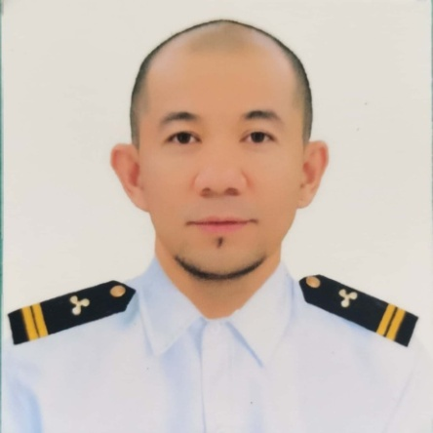

LESTER B. CRISTOBAL
Blk. 17 Lot 4 Village 1 Deca Homes & Residence Pandac Iloilo City Philippines
Phone # +63 9613300777 / +63 9757185700
Email add: lestercristobal03@yahoo.com

OBJECTIVES:
Committed, and reliable employee as seafarer over 15 years worth of experience hard working passionate and loyal to the company. Seeking added responsibilities to help business operations runs smoothly .Currently holding a visit visa and willing to work and perform my duties well to support my family .

Skill:
-Driving
-Overhauling of water pumps
-Overhauling of sea water pumps
-Overhauling of fuel oil purifiers
-Overhauling of Deck Air Compressor
-Overhauling of Main Air Compressor
-Overhead Crane Operator
- Welding
-Carpentry

EDUCATIONAL BACKGROUND:

COLLEGE: 2001-2004 Bachelor of Science Marine Engineering
St. Therese MTC Colleges Magdalo Street La Paz Iloilo
City , Philippines 5000

HIGH SCHOOL: 1996-2000 – Notre Dame of Upi
Nuro, Upi Maguindanao Philippines

ELEMENTARY: 1990-1996 Nuro Central Elementary School

WORK EXPERIENCE: Maryville Manila Inc. Maritime Agency
Job Hire: 4th Engineer
Vessel Name: M/V agivc Venus
Type of Vessel: Cargo Vessel
Trading Area: Worl Wide
Inclusive Date: Nov. 2020-October 2022
Remarks: Finish Contract

Sea Guardian Maritime Corp. Job Hire: 4th Engineer
Vessel Name: M/T Euro Glory
Type of Vessel: Tanker Vessel
Trading Area: World Wide
Inclusive Date: June 2019 to Feb 2020
Remarks: Finished Contract

Sea Guardian Maritime Corp. Job Hire: Oiler Promoted to 4th Engineer
Vessel Name: M/T Euro Glory
Type of Vessel: Tanker Vessel
Trading Area: Worl Wide
Inclusive Date: May 2019 to June 2019
Remarks: Finished Contract

Wilhelm Smith Bell Manning Inc. Job Hire: Motorman
Vessel Name: M/T Alpine Loyalty
Type of Vessel: Tanker Vessel
Trading Area: Worldwide
Inclusive Date: February 2012 to December 2018
Remarks: Finished Contract

Status Maritime Corp. Job Hire: Motorman
Vessel Name: M/T Paloma C
Type of Vessel: Tanker Vessel
Trading Area: World Wide
Inclusive Date: November 2006 to March 2011
Remarks Finished Contract

Reference: Arturo Madamba Jr - 780 885 2313
Francis Joy Sorongon- 780 710 0217
Jacky Arado - 587 589 6911

