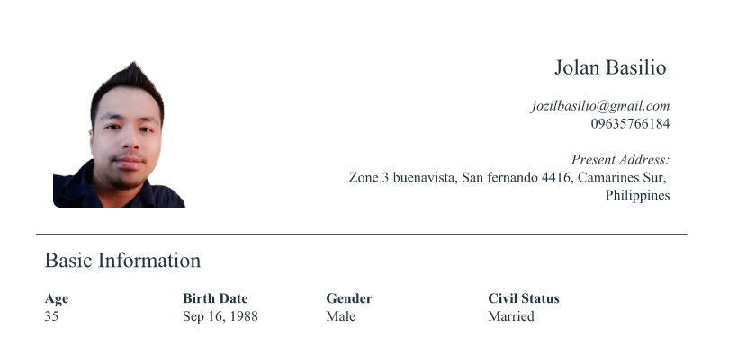

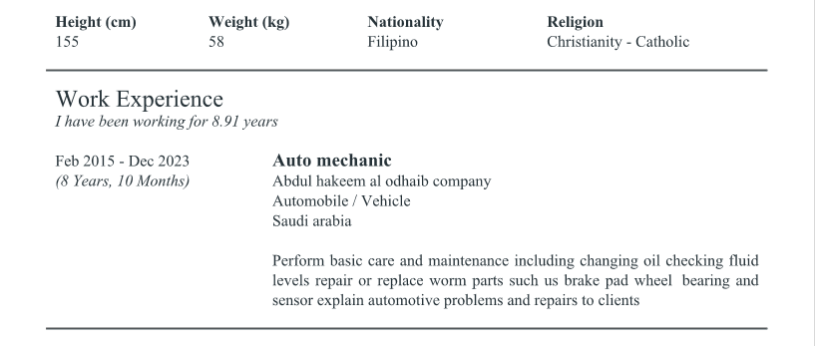

Brand of Cars Handled Ford
GMC
Chevrolet
Honda
Toyota
Lexus
Kia
Hyundai
BMW
Mercedes Benz
Nissan
Land Cruiser





