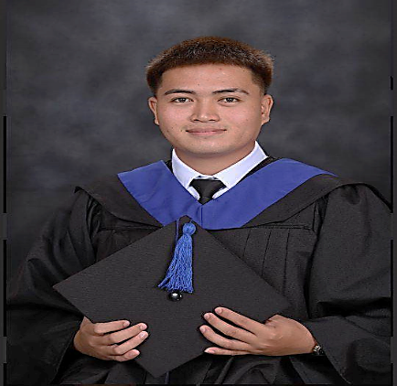
Teamwork
42647 Time Management

JUSTEEN S. LIBU
0992-839-5672/0981-023-8745
/09
Purok 1, San Rafael (Duck Island), Lubao,
Guagua, Pampanga
justeenlibu@gmail.com
CONTACT
SKILLS
Time Management
Verbal & Written
communication
English
Filipino
LANGUAGE
PROFESSIONAL PROFILE
EDUCATION
Don Honorio Ventura State University
Bachelor of Science in Industrial
Technology

Performing Roughing-In Activities, Wiring, and Cabling Works for
Single-Phase Distribution, Power, Lighting, and Auxiliary Systems
Tesda Online Programs
I
N
D
U
S
T
R
I
A
L

T
E
C
H
N
O
L
O
G
Y
G
R
A
D
U
A
T
E
An independent and self-motivated graduate looking for an entry-
level position in the marketing department where I can utilize the
extensive knowledge I have gained during my course. Well versed in
market research and excellence in creating brand awareness.
Major in Electrical
DHVSU Main Campus, Villa de Bacolor, Pampanga
School Year 2018 - 2022
Installing Electrical Metallic/Non-metallic (PVC) Conduits
Installing Wireways and Cable Trays
Installing an Auxiliary Terminal Cabinet and Distribution Panel
Performing Wiring and Cabling Layout
Installing Wiring Devices for Floor and Wall Mounted Outlets,
Lighting Fixtures, Switches and Auxiliary Outlets
Installing Lighting Fixtures/Luminaires and Switches
Installing Auxiliary Outlets
Becuran High School
Senior High School 2016 - 2018
Technical Vocational
Major in Electrical Installation Maintenance NC II
Junior High School 2012 - 2016
Becuran, Sta. Rita, Pampanga
Willing to undergo training
Character Reference available upon request
CONTINUING PROFESSIONAL DEVELOPMENT
WORKING EXPERIENCED
January 2022-2023
BFF Construction
EDUCATIONAL BACKGROUND
PROFESSIONAL PROFILE

