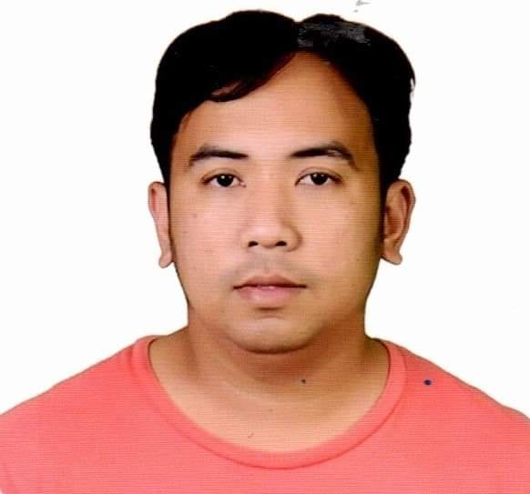
NOVILLA, MICHAEL VELASCO

#547 Toress Street, Panasahan, City of MalolosBulacan
Mobille No.: +63997-063-8419/ +63943-283-8366
Emai Address: Novillamichael28@gmail.com

OBJECTIVE:

To apply what I have learned and do my work where the acquired skills, knowledge and experiences will be utilized.

PERSONAL DATA:

Date of Birth : June 14, 1989
Place of Birth : Malolos, Bulacan
Civil Status : Married
Age : 33 years old
Religion : Roman Catholic
Height : 5’6
Weight : 72 kgs.
Sex : Male
Citizenship : Filipino

EDUCATIONAL BACKGROUND:

Primary : Panasahan Elementary School
Panasahan, City of Malolos, Bulacan
1995-2001

Secondary : Malolos Marine Fishery School and Laboratory
Balite, City of Malolos, Bulacan
2001-2005

Tertiary : Bulacan Polytechnic College
Computer Technician
2006-2008

Vocational : Technical Education Skills and Development Authority (TESDA )
Machining
January2010–May2010

WORKING EXPERIENCE:

MATECH B.T.A.
St. Charles, Drummondville, QC
June 6, 2023 to Present

Job Description
Classify and opening a torque converter, cleaning and washing will carry out machining and reconditioning of parts using machine tools.

CHENGTECH CORPORATION
Milling Operator
Tabe Guiguinto Bulacan
September 2019 to Present

Job Description
Can make semi conductor parts like chipset, die and casting etc.
Compute dimensions, tolerances and angles of work pieces or machines according to specifications and knowledge of metal properties and shop mathematics.

LUEL ENGINEERING SERVICES
MILLING OPERATOR
January 2018-August 2019

Job Description
Making some sealers, cutter blades for food processing.
Position and secure workplaces on machines, using holding devices, measuring instruments, hand tools and hoists.

CDS Machine Shop Corporation
Lathe/Milling Operator
July 2017-January 2018

Job Description
Verify alignment of work pieces on machines using measuring instruments such as rules, gauges or calipers.
Making acrylic boxes and aluminum.

QUALITY MACHINING SERVICES
Lathe/Milling/Radial/Boring Machine Operator
Dammam,Kingdom of Saudi Arabia
May 2015-June 2017

Job Description
Can make rotor, bolts and nuts, screw in lathe machines and reboring and drilling ang keyways in milling machines.
We can drilling also some plunges in radial machine.
Sometimes we have to much work in the shop and no available milling machine we can squaring and slotting in shaper machines.

MILLING OPERATOR
CHENG ENGINEERING
TABE GUIGUINTO BULACAN
JULY 2012-MAY 2015

JOB DESCRIPTION
Remove Workplaces from machines and check to ensure that they conform to specifications, using measuring instruments such vernier calipers,micrometers, dials, pitch gauge etc.

MILLING/LATHE MACHINE OPERATOR
CDS Machine Shop Corporation
Tabe Guiguinto Bulacan
August 2010-June 2012

Job Description
Study blueprints, layouts, sketches or work orders to assess workplace specifications and to determine tooling instructions, tools and materials needed and sequences of operations.

TRAINING AND SEMINAR ATTENDED:
ON THE JOB TRAINING ( OJT )
CDS MACHINE SHOP CORPORATION
May 4, 2010 – July 27, 2010

SKILLS:
Can operate Milling/ Lathe Machine/Radial/Surface Grinding
Can speak English and Tagalog

CHARACTER REFERENCE:
GERRY P. MANIMTIM CHERRIE ANN C. CRUZ
Production-Head Admin-Head
Chengtech Corporation Chengtech Corporation
Tabe, Guiguinto, Bulacan Tabe, Guiguinto, Bulacan
+63919-203-1555 +63931-189-3014

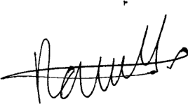

___________________________
MICHAEL V. NOVILLA

