
REYMARK REBALBOS LORETE
: ZONE 8 Sampaguita, Lipa City, Batangas
: 09066904806
: reymarklorete7@gmail.com

PROFESSIONAL OBJECTIVES
To join a prestigious company where:
- I could assist and contribute to its growth and success.
- I could practice my professional know how.
- The Lord’s headship is recognized.

- Highly skilled machinist with 12 years extensive experience in operating (LATHE, MILLING, SURFACE GRINDER, SHAPER, CNC) and other machine shop tools and equipment’s.
- Always seeking for improvements in every aspects of jobs.
- Accepts challenges and new learnings for improvement.
- With a CAN-DO attitude and can work as one-man team/multi-tasking.
- National Certified and Graduate of vocational course in Machining.
- Well experienced in welding (SMAW, TIG, MIG, OXY ACETYLENE)

WORK EXPERIENCE

May 2023 - Present
OPTIMUS SPORTS AND DEFENSE ENTERPRISES
Sampaguita, lipa, Batangas
Position: Machinist/Machine operator/Fabricator
Duties and Responsibilities
- Fabricating parts using lathes, milling and surface grinding machine.
- Using correct machining methodology
- Quality controlling of own parts
- Manufacturing components to required tolerances
- Ensuring all work is completed to a high standard and safety guidelines are followed

March 2020 - February 2023
QUICKFAB INNOVATIVE PRODUCTS INC.
Santor, Malolos, Bulacan
Position: Tool and Die Machinist/fitter
Duties and Responsibilities
- Making tools and dies used for punching, piercing, forming, notching sheet metals
- Maintaining and repairing parts of machineries used in production
- Researching and innovating tool for much efficiency and time effective to increase production
- Taking responsibility for in house general maintenance tasks
- Providing mechanical and technical support to the scientific or engineering staff
- Playing a key role in growing safety culture
- Attending breakdowns and identify faults and problems with press tools and roll forming machines
- Using and identifying correct machining methodology
- Quality controlling of own parts
- Manufacturing components to required tolerances
- Use math trigonometry to find unknown dimensions

January 2017 - February 2020
DEQ AGRI MACHINERIES AND SUPPLY
Polangui, Albay
Position: Chief Machinist
Duties and Responsibilities
- Responsible for all machining process using Lathe Machine, Milling Machine, Welding Machine and all basic machine shop tools and equipment’s.
- Ability to use solely manual machining techniques
- Using correct machining methodology
- Using math and trigonometry to find unknown dimensions

July 2015 – November 2015
SANFORD MARKETING CORPORATION
Molino 4, Bacoor, Cavite
Position: Supply Bagger
Duties and Responsibilities
- Packaging of parcels and customer groceries
- Assisting customer and helping them load and unload their groceries
- Daily inventory of front desk supply such as paper bags, eco bags
- Checking and supplying paper bags, eco bags and thermal paper in front desk
- Daily checking, cleaning

September 2012 – December 2014
DEMATECH PRECISION AND TRADING CORPORATION
Loma, binan, Laguna
Position: CNC Operator/Programmer/machinist
Duties and Responsibilities
- Responsible in producing parts using CNC Milling Machine.
- Operating, setting up and change over CNC Machines in a precision manufacturing environment.
- Meeting production goals and delivery schedule as assigned by supervisor
- Understanding and interpreting engineering specifications and apply to manufacturing processes
- Using basic inspections instruments (Calipers, Pin Gauges, Micrometers, Dial gauges, Gauge blocks)
- With willingness to learn multiple types of machines to support business needs as required

April 2011- September2012
EUDEN ENTERPRISE AND TRADING SERVICES
Cainta, Rizal
Position: machinist
Duties and Responsibilities
- Turning and milling parts and meeting it’s given tolerances
- Use math and trigonometry to find unknown dimensions
- Interpreting, analyzing and reviewing assigned drawings and work orders
- Manufacturing parts to required tolerances
SKILLS

- Proficient in operating (Lathe, Milling, Surface Grinder, Shaper Machines, CNC) and various machine shop tools and equipment’s
- Knowledgeable in Welding (SMAW, TIG, MIG)
- CAD and CAM design
- Preventive maintenance
- High job analytical and problem-solving abilities
- Adaptable and having comprehension skill

EDUCATIONAL ATTAINMENT
Vocational Education
School: Sisters of Mary Technical Educational Institute Cavite Inc.
Course: MACHINING NATIONAL CERTIFICATE 2
Address: Adlas, Silang, Cavite
School Year: 2011-2012

Secondary Education
School: The Sisters of Mary School
School Year: 2008-2012

Elementary School
School: Balogo Elementary School
School Year: 2004-2008

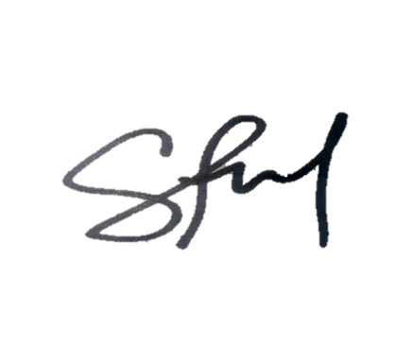
I hereby state that all the information noted above is accurate to the best of my knowledge and beliefs and I take full responsibility for the correctness of the information.

_______________________
Reymark R. Lorete

