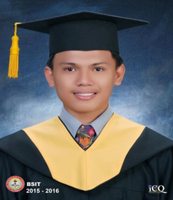
ERNIE JAY C. ESTRELLOSO

Address: Sangat San Fernando, Cebu Contact number: (+63) 926-029-0116
Email add: erniejayestrellosojay@gmail.com

EDUCATION

(2012-2016) - BS in Industrial Tech. Major in Electrical Technology – Cebu Technological University

SKILLS

- Computer literate: Encoding, MS Application, (Microsoft Word, Excel, PowerPoint, etc.)
- Responsible, blends well with different personalities, well organized and flexible
- Automation Electrician, building wiring

WORK EXPERIENCE

Procestech
Zagreb, Croatia
October 2023 – Present

- Automation Electrician
- Cabinet installer and wiring cables

LGU San Fernando
San Fernando, Cebu
November 2019 – October 2023

- Electrical Maintenance
- Supervisor
- Reading plan and Paper works
- Inspector

Gigatech Inc.
Cebu City
June 2017 – June 2018

- Understanding and Reading electrical wiring diagram or layout
- Building wirings for lightings, auxiliary, convenience layout
- Lay outing, piping and installing
- Lead man or in charge of other work

Phil-Union Frozen Foods, Inc.
Mepza 1 Brgy. Ibo, Lapu-Lapu City, Cebu
May 2016 – February 2017

- Motor Controls
- Installation of Electrical controllers and relays
- Installation and wiring of controller for liter
- Installation and wiring of controller for condenser and evaporator for ACU
- Installation and wiring of controller for condenser and evaporator for chilling rooms
- Trouble shooting fault of electrical equipment’s
- Terminating #200mm wire for Manual Transfer Switch (MTS)
- Electrical systems for water supply pumps and controllers

CHARACTER REFERENCES

ENGR. JOB MALOLOY-ON MR. TOMISLAV SARONJA
Head CEO
Phil-Union Frozen Foods, Inc. Procestech
(+63) 905-798-9021 +385 98 636 251

ENGR. JOHN KENT M. LAURONAL
Municipal Engineer
LGU San Fernando
(+63) 995-894-2209

