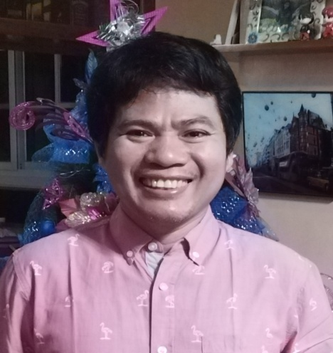

Phone #: 1(143)79617614

Email address: batarina.edison@yahoo.com

3257 Sheppard Ave., East Scarborough, ON. M1T3P1

Education

Bachelors degree
Mechanical Engineering
1997-2002

Skills

Plumbing
Ms office
Basic Welding
Driving

Language

English

EDISON BATARINA

Profile

Graduate of Degree in Mechanical Engineering with 10 years experienced as Hotel Maintenance Plumber in a Cruise line industry and machine operator in a clean room electronics factory for 2 years.

Work Experience

2006-2008 Acer Unipac Optronics
Longtan,Taiwan
Machine Operator

●Assemble of electronics components(pcb, cof soldering , glass panel)
●Testing and ageing of finished assembled television screen
●Repair malfunction television screen
●Sorting return television for repair according to defects
●Prepare boxes for costumer delivery

2014-Present Aida Cruises
Magsaysay Maritime Corporation
Manila, Philippines
Service Technician Plumber

●Install, repair, and maintain pipes, valves, fittings and fixtures
●Respond to, diagnose and resolve pipe line blockage
●Familiar with Maritime waste disposal regulation
●Work in extreme temperatures or areas with high humidity
●Ensure ships sewage, gray water and black water system are functions properly to prevent blockages and leaks as ensuring environmental regulations
●replace broken plumbing fixtures
●Replace leak and broken pipes

