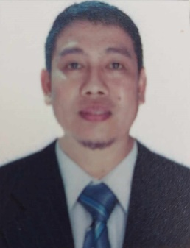

Alberto Globo Lee
Butcher/ Slaughter
HOME ADDRESS :M.H. del Pilar Street Rizal, Roxas, Isabela
CELLPHONE NO. 0965-456-0865/0991-600-3867
EMAIL ADDRESS: pilikitot20@gmail.com FACEBOOK NAME: Albert lee

Career Objective
Seeking a Butcher position with a well established company where my skills are implemented and enhance.
Skills: Ability to work under pressure, team player, excellent communication skills, fast learner, dependable, punctual, honest with integrity, great multitasker, ability to lift and carry heavy objects and also Ability to work in poor weather conditions, including heat, cold, rain, and snow.

Work Experience
Slaughterhouse April 15,2020 up to present
Slaughterer / Butcher
Job Duties:
- Stunning the hog
- Sticking
- Moving the hog into the scalding vat
- Scraping table for the of remaining hair and removal of hooves
- gambrel Ing
- Singeing by means of blow torch
- Shaving
- Washing
- Cut chest bone
- Evisceration
- Split carcass
- Final Washing
- Trimming
- Weighing and labeling of the carcass

Education
Tertiary:
Aemillianum College Incorporated
Computer Technician ( Undergraduate)
Sorsogon City, Sorsogon
S.Y 2005-2006
Secondary:
Sorsogon, State, College (Laboratory High School)
Sorsogon City, Sorsogon
S.Y. 1998- 2001

Certifications
Certificate of Training In Slaughtering Operations (SWINE NCII)
Date Attendance: 2023-27-03 to 2023-09-05
Date Completion: 2023-10-05
Training Company: Northeast Luzon Skills and Technical School Inc. (TESDA Accredited)
Maharlika Highway, San Placido, Roxas, Isabela

IELTS Band Score
Listening - 5.0
Reading – 4.5
Writing – 5.5
Speaking – 5.0
Overall Band Score 5.0

Personal Information  Age: 39 years old  Date of Birth: 01-10-1985  Birthplace: Sorsogon City, Sorsogon  Sex: Male  Civil Status: Married  Citizenship: Filipino  Height: 5’7  Weight: 70kgs | References  Roberto C. Corpus  School Administration  0969-171-7162  Amado De Luna  Senior Meat Inspetor  Double AA Slaughterhouse (Municipality of Roxas)  0953-284-5052  Arthur Magtalas  Private Secretary  (Office of the Mayor)  0953-165-9029

