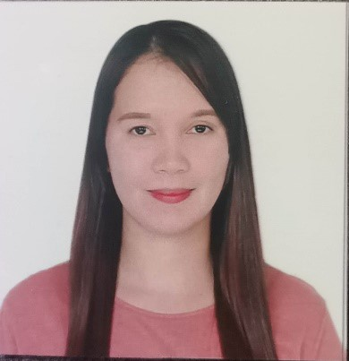
M
A
.
A
B
E
G
A
I
L
E
.
D
I
E
G
O
A
d
d
r
e
s
s
:
M
A
L
A
B
O
K
A
L
A
N
T
U
K
A
N
L
I
L
I
W
,
L
A
G
U
N
A
M
o
b
i
l
e
N
o
:
0
9
1
5
2
3
1
9
3
5
9
E
-
m
a
i
l
a
d
d
r
e
s
s
:
n
a
y
r
b
1
1
1
7
@
g
m
a
i
l
.
c
o
m
OBJECTIVES: TobeabletoworkinacompanywhereinIcanapplymyknowledgeand skillinthefieldI’vechosenandrenderserviceforthebettermentaswellasformycareer growthandpersonaldevelopment.
PERSONAL INFORMATION:
DATE OF BIRTH | : | November 17 1992
AGE | : | 31 yrs old
PLACE OF BIRTH | : | Liliw,Laguna
CIVIL STATUS | : | Single
CITIZENSHIP | : | Filipino
RELIGION | : | Roman Catholic
LANGUAGE | : | English / Tagalog
HEIGHT | : | 165cm
WEIGHT | : | 55'kg

EDUCATIONAL BACKGROUND:
SECONDARY:
SCHOOL | : | Calumpang National High School
ADDRESS | : | Calumpang Nagcarlan Laguna
DURATION | : | School Year 2008-2009
PRIMARY :
School : Calumpang Elementary School Address : Calumpang Liliw, Laguna DURATION : School Year 2004-2005
CERTIFICATE
-Complete 160Hours of Internship -LPH General Cailles Memorial District Hospital ( September 25,2023 to October 5,2023)
-CARGIVING NCII ( CERTIFICATE No. 23043402040880)
WORKING EXPERIENCE______________________________________________________
*SUN STAR - Brgy Gatid Sta.Cruz Laguna
Position ; Cashier (2011)
*CANON BUSINESS MACHINE PHILIPPINES INC - FPIF Sto.Tomas Batangas
Position : BM INSFECTOR (2018-2019)
*RED RIBBON ZENITH CORPORATION – Brgy Canlubang Calamba Laguna
Position : Production (2022)
SKILLS AND INTEREST:
*Cooperative, Patience, Follow instruction and Easy to learn *Reading informative books and references.
*Leadership Skills
Character And References
Michael Diego
Brgy. Captain
Malabo-Kalantukan Liliw, Laguna
Iherebycertifythattheaboveinformationsaretrueandcorrecttothebestofmyknowledge.

MA.ABEGAIL ESTRADA DIEGO

