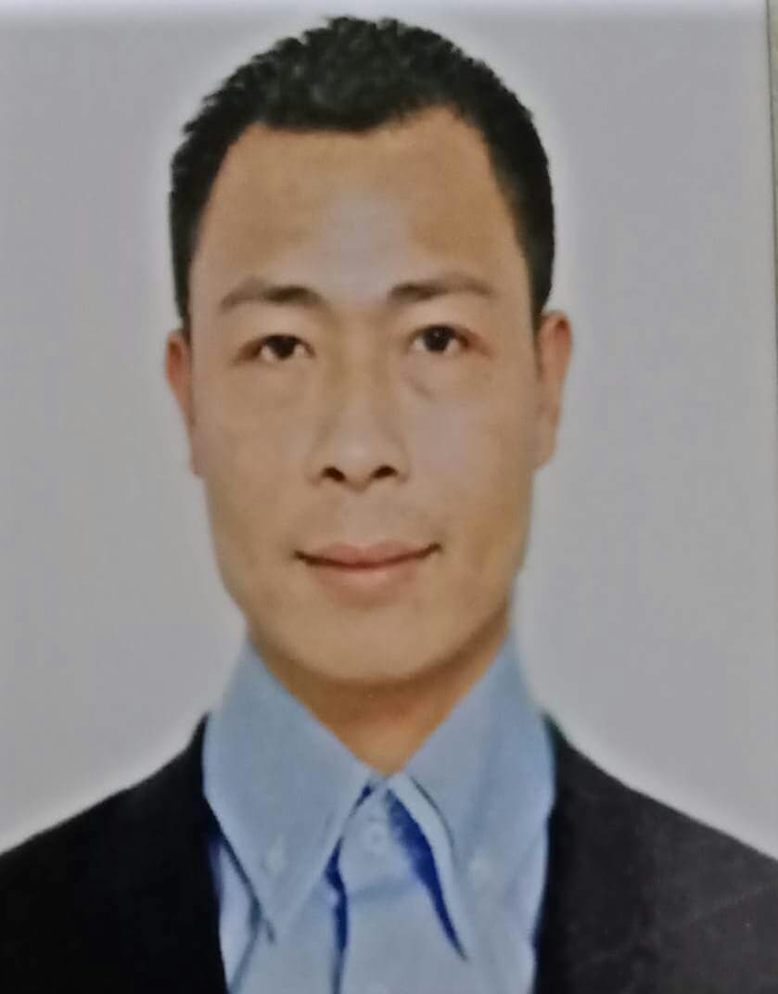
ERNESTO D. PAQUERA
E-mail address: ernesto.paquera09@gmail.com
Philippines Address: Blk.11 Lot 26 Walnut St., Metro Manila Hills Communities,
San Jose Rodriguez, Rizal, Philippines
Cell Phone #: +639955485645

PROFESSIONAL SUMMARY AND SKILLS
Spa Attendant with long years of experience and excellent customer service skills. Intensive understanding on handling guests preferences on spa experience at pool, sauna and steam. Strongly organize on the equipments, locker amenities and health bar/ food servicing.

HIGHLIGHTS
- Highly punctual and meets deadlines
- Customers’ service oriented and anticipatory with guests preferences
- Strongly organized and professional grooming
- Well trained on handling spa equipments and safety measures
- Detailed and accurate inventory skills
- Hygienic and cautious in food servicing

PERSONAL AND EDUCATION BACKGROUND
Stands 5’7” and weighs 135 lbs. Married with one son. I have basic knowledge of Microsoft Office Word and Microsoft Office Excel Application. Punctual, dedicated, and responsible on the tasks impose. I’m an efficient and hardworking team player. I’m capable of working beyond duty hours if needed in operations. Easy to learn with minimum supervision and willing to be trained in different field if opportunity given. Completed primary and secondary level dated 1993 and 1998 respectively. Taken Vocational Course at Asian Institute of Computer Studies dated 2002 and Special Course on Basic Housekeeping at Mandarin Oriental Manila dated 2008.

WORK EXPERIENCE

REAL ESTATE SALESPERSON:
May 1, 2022-present /New San Jose Builders Inc. /Philippines
- Professional recommendation on preselling and ready to occupy house and lot as well as condominiums.
- Resposible in the documentation process and assistance to clients in terms of priority listings and reasonable, affordable property.

GUEST SERVICE ATTENDANT
December 28, 2009 to March 31, 2016 Taivex Malo Day Hospital/ SPA, Venetian Resorts and Hotel Ltd., Macau
- Team Leader for guest service attendant staff in facilitating and distributing daily and weekly tasks.
- Responsible in weekly inventory of spa amenities and stocks of cleaning materials used in maintaining the good standard of spa facilities.
- Monitoring weekly condition of wet/dry facilities such as Hammam/Sauna and locker standard protocols.
- Retailing Food and Beverage such as drinks and health food to provide health benefits before or after their spa treatments.
- Excellent rapport and enthusiastic approach in handling guest’s preferences for their spa visit.

SPA LOCKER ATTENDANT
August 10, 2007 to May 5, 2008 Suriya Spa, 3rd Floor Glorietta 3 Branch, Philipppines /DAY SPA
- Responsible for handling and organizing bath towels, robe, shorts, slippers inside the locker.
- Operating the Sauna and/or Steam and assisting the clients for detoxification prior to their treatments.
- Maintaining the locker area clean and hygienic by ensuring clients’ health benefits.
- Cleaning and sanitizing restroom facilities and fixtures including sinks, urinals, and toilets.
- Checks supplies to ensure adequate availability, and order new supplies when necessary.

SPA/FITNESS LOCKER ATTENDANT
July 12, 2004 to January 8, 2007 Pinnacle Health Pointe, Philippines /FITNESS AND SPA
- Well-trained and thorough working knowledge of the equipments, materials and methods used in cleaning spa facilities such as Jacuzzi, shower rooms, urinals, and locker area.
- Directly responsible in handling towels for gym use, assisting clients on spa facilities by providing accurate service.
- Checking and maintaining gym equipments’ cleanliness before the operation start and assisting fumigation once a week during graveyard duty.
- Facilitates and maintaining the best condition of floors by sweeping, mopping, waxing, and polishing floors; vacuuming and shampooing carpets.
- Well-trained in arranging the spa facilities based on basic standard technique with the organized setting of beds, linens and towels used on spa treatments.

STOCKMAN
August 9, 2003 to January 8, 2004 Hardware Workshop Inc./SM North EDSA Branch, Philippines/ DEPT. STORE
- Checking weekly inventory on hardware, electrical and car apparel, examine and inspect stock items for wear and defects by reporting any damage to supervisor.
- Clean and maintain supplies, tools, equipments in storage areas in order to ensure compliance with safety regulations.
- Determine proper storage methods, identification, and stock location based on turn-over, environmental factors, and physical capabilities of facilities.
- Pack and unpack items to be stocked on shelves, marking items using identification tags, stamps, electric marking tools or other labelling equipments, and stockrooms, warehouses and storage yards. Issue or distribute materials, products, parts and supplies to customers or co-workers based on information from in-coming requisitions

CHARACTER REFERENCES
Brian Tang
Director and Training Consultant
E-mail address: cdo@dingmaker.com (+853) 62110791

Keith Balquin
Fitness Trainer (Sands Cotai Limited)
E-mail address: keithbalquin@yahoo.com (+853) 62918187

I hereby certify that the above information is true and correct with the best of my knowledge.

________________________
ERNESTO D. PAQUERA

