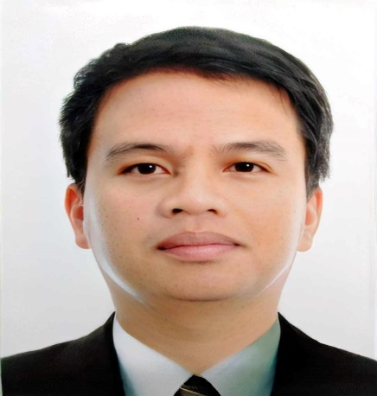

Beverly Bryan Q. Balan

Contact Info

Address : Block 5, Lot 28 Quilib, Rosario Batangas
Mobile No. : +639295013715
Email : bryanbalan@gmail.com

Personal Particulars

Age : 40 years old
Date of Birth : February 01, 1984
Nationality : Filipino
Gender : Male
Marital Status : Married
Permanent Residence : Philippines
Languages Spoken : English, Filipino

Educational Background
Tertiary Level

Field of Study/Major : BS Engineering Technology Management
Institute/University : MSU-Iligan Institute of Technology
Graduation Date : Oct.2008 to 2010

Field of Study/Major : Civil Engineering Technology
Institute/University : MSU-Iligan Institute of Technology
Graduation Date : April 2008

Field of Study/Major : General Education
Institute/University : MSU-Iligan Institute of Technology
Graduation Date : June 2001-March 2003

High School

Institute/University : Iligan City East High School Sta. Filomena
Graduation Date : March 2000

Career Objective

- To engage in good reputation works that will grant great avenues for integration and application of Safety Standards, Safety Policy of the company and be able to gain, learn and find opportunities for career growth and advancement
- To use my skills and education to contribute towards developing and expanding business opportunities.

- To seek a full time and permanent job position with the opportunity for professional growth and advancement.

Company Experience

1. Company : Republic Cement Building Materials
CRH- Aboitiz Company
Position : KILN Senior Control Room Operator
Company Industry : Cement Manufacturing Plant
Duration : April 2022 - to Present
Department : Production Department

2. Company : Republic Cement Building Materials
CRH- Aboitiz Company
Position : Control Room Operator
Company Industry : Cement Manufacturing Plant
Duration : August 2016 - April 2022
Department : Production Department

3. Company : Republic Cement Corporation- Lafarge
Position : Raw Milling / Crusher Operator
Company Industry : Cement Manufacturing Plant
Duration : October 2013 – August 2016
Department : Production Department

4. Company : Republic Cement Corporation- Lafarge
Position : Safety Officer Incharge ( Demolition )
Company Industry : Cement Manufacturing Plant
Duration : February 2012 - Present
Department : Safety Department

5. Company :WORLD SAFETY ORGANIZATION (WSO)
Position :EHS Officer (Construction)
Company Industry :CCBPI Greenfield Project
Duration :October 06,2010 - Present
Department :Safety Department

6. Company :Grand Ace Cardinal Industrial Inc.
Position :Safety Officer (Industrial)
Company Industry :Lafarge Company/Iligan Cement Corp.
Duration :July 2009 – October 2010
Department :Safety Department

7. Company :AVILA Painting and Lettering Services
Position :Safety Officer (Industrial)
Company Industry :Pilmico Foods Corporation
Duration :October 2006 –June 2009
Department :Safety Department

References
Name : Mel Gerpacio
Relationship : Employer
Position : WSO-Human Resourse Manager
Tel.No. : 09209500110

Name : Oliver Ceniza
Relationship : Shift Manager
Position : Production Line- Manager
Tel.No. : 09178630247
Name : Mr. Alladin A. Avila
Relationship : Employer
Position : Proprietor, De Avila Painting and Lettering Services
Tel.No. : 09089241765

