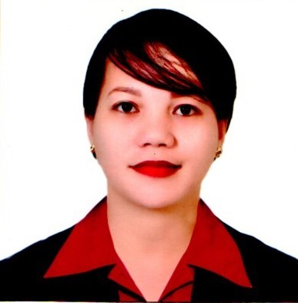
MEYRA FE B. AYUBAN
Purok 28-C, Kawayanan, Madaum,
Tagum City, Davao Del Norte, 8104
Email: meyrafeb@yahoo.com/meyrafeb1112@gmail.com
Passport No: P40804980
Cellphone No: +639603156754

OBJECTIVE:

Aim to further develop my skills and career in the butchery industry. Potentially taking on more responsibilities and ensuring that the company’s goal geared and anchored on productivity and profitability.

I-EDUCATIONAL BACKGROUND:

VOCATIONAL:
Computer Secretarial
Davao Northphil Institute of Technology, Inc.,
Mankilam, Tagum City
March 2009

SECONDARY:
Limbaan National High School
Limbaan New Corella, Davao del Norte
March 2007

II-TRAININGS & SEMINAR:

Meat Cutting & Deboning
Nonits Training Center
July 24. 2023-September 2, 2023

Good Manufacturing Practices
Food Safety Orientation
National Meat Inspector Services
Evacuation Center, Malalag, Davao Del Sur
August 8, 2023

III-WORK HISTORY:

BUTCHER/DEBONER
JADRAQUE MEATSHOP
July 2, 2018 – July 7, 2023

Duties & Responsibilities:

- Keeping meats in freezers or refrigerators at the proper temperature.
- Sharpen and adjust cutting tools and knives.
- Cut and debone meat into small pieces.
- Weigh, package, and present meat or met products.
- Maintain hygienic and safety standards by keeping the workspace and equipment clean.
- Receive, check, and store meat as soon as it is delivered.
- Cut or prepare meats in accordance with specifications or clients’ requests.

IV-SKILLS:
- Knife handling and sharpening.
- Cutting & Trimming of meat.
- Operating meat processing equipment.
- Customer service.
- Maintaining proper food safety and hygiene standards.
- Outstanding communication and interpersonal skills.
- Organized.
- Strong time management.
- Keen to details.
- Computer literate.
- Driving

V-PERSONAL DATA:
Birthplace : Limbaan, New Corella, Davao
Birthdate : November 12, 1990
Civil Status : Married
Citizenship : Filipino
Languages : Bisaya, Tagalog, English

VI-CHARACTER REFERENCES:
Mrs/Mr : Arnel Jadraque
Position : Owner
Company : Jadraque Meatshop
Address : Poblacion Matanao, Davao del Sur
Contact No : +639510912562
Email Address: jadraquea0@gmail.com

