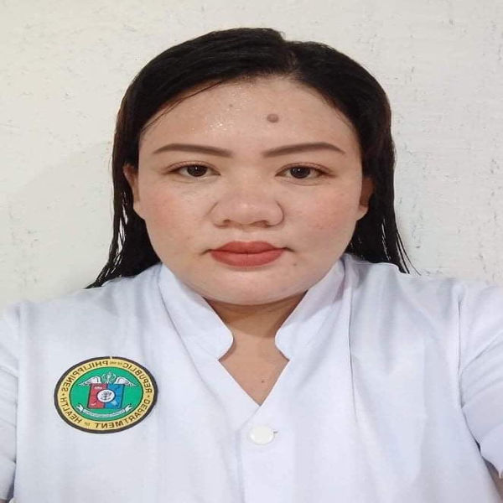
Dedicated and compassionate Registered Nurse (RN) with progressive career history in direct patient care, triage and care coordination in fast-paced environment. Proven to remain calm under pressure and skillfully handle difficult patients and high-stress situations. Consistently developing strong relationships with patients and families through empathetic communication, respectful attitude and excellent customer service. Hardworking Registered Nurse with success providing individualized patient care. Committed to delivering best-in-class patient care through effective education and counseling. Proven leadership focused on increasing and enhancing patient care and satisfaction. Streamline safety protocols for comprehensive patient care. Hardworking and passionate job seeker with strong organizational skills eager to secure entry-level Nurse position. Ready to help team achieve company goals. Organized and dependable candidate successful at managing multiple priorities with a positive attitude. Willingness to take on added responsibilities to meet team goals.

LYN
AIRESSE
MARIBAO
WORK HISTORY
REGISTERED NURSE
NURSE II
Ronda Primary Care Facility
- Administered vaccines for Immunization for children 0-12 months old
- Do Family Planning Counseling and provision of Family Planning Method
- Administered medications for Mental Health Gap Action Programme Patients
- Administered medications via oral, IV, and intramuscular injections and monitored responses.
- Updated patient charts with data such as medications to keep records current and support accurate treatments.
- Assessed patients to determine individual needs and develop care plans in coordination with multidisciplinary healthcare professionals.
- Collaborated with physicians to quickly assess patients and deliver appropriate treatment while managing rapidly changing conditions.
- Performed routine wound care and dressing changes on schedule.
- Came up with treatment plans and communicated with patients about options, medications and self-management.

ENGLISH ONLINE TUTOR
Real Great English

- Taught English language to foreign students in online setting.
- Evaluated students' abilities and grasp of English language, keeping appropriate records and preparing progress reports.
- Expanded student understanding of texts by spearheading in-depth discussions and assigning exploratory essays to help students articulate knowledge.
- Employed diverse teaching approaches to help students of all abilities understand material.

2015-11
CURRENT

2013-01 –
2015-06

Contact

Address
STA CRUZ RONDA, CEBU,
PHILIPPINES 6034

Phone
+639392986537

Email Address
zolynsebino88@gmail.com
Skills

Nursing staff leadership
Intravenous therapy/ IV set up
Patient and family advocacy
Vaccine administration
Family planning services education
Personal care needs
Postpartum counseling
Removing sutures
Patient counseling
Physical assessments
Disease Surveillance and Response

Education

2023 – 02
2020 – 09

2020 – 02
2020 – 02
2020 - 02
2020 – 01
2018 – 03
2016 - 07

1995-06 –
2000-06

Basic Life Support – Cardio Pulmonary Resuscitation
Donning/Doffing, Nasopharyngeal Swab/Oropharyngeal Swab Specimen Collection
FUNDAMENTALS IN PHLEBOTOMY
R.A 10912: PRO et CONTRA
Standard of Practice: Infusion Therapy (2016 INS Guidelines
Bloodborne Pathogens 2015 OSHA Guidelines
3 Day Disease Surveillance and Response Training
Family Planning Competency Based Training Level I

Certification
2004-06 -
2008-06

2000-06 –
2004-06

1995-06 –
2000-06

Bachelor of Science: Nursing
UNIVERSITY OF CEBU- BANILAD, CEBU CITY

High School Diploma
OUR LADY ACADEMY – POBLACION RONDA

Primary School
STA. CRUZ ELEMENTARY SCHOOL – STA. CRUZ RONDA CEBU

