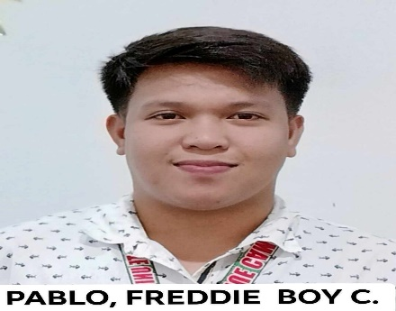

CAREER OBJECTIVE
To obtain a position that challenges me and provides me the opportunity to reach my full potential professionally and personally utilizing my abilities and years of experience in your organization that is progressive intellectually and technically and one in which practices integrity and honesty.
- Communication
- Problem Solving
- Leadership
- Time Management
- Decision Making
- Team Oriented

SKILLS

FREDDIE BOY C. PABLO
Applicant
EXPERIENCE
Isabela State University / Administrative Aide I.

MAY 4, 2021 – PRESENT
- Act as Customer Service Representative/Information Desk.
- Answered queries & complaints of the customers ( Facebook, Emails & Face to Face transactions).
- Sorting and preparing bulk files for packaging and delivery.
- Assisted for the evaluation of Scholarship applicants for Merit, CHED TDP and etc.

RD Pawnshop / Management Trainee.

(FINISHED 4 MONTHS) in 2021
- Selling and Appraising Gold.
- Roving MT, relieving 7 Branches in a week.
- Collecting transaction for E-pay ( Gcash, Bills Payment and etc, )

Save More Super Market / Selling Clerk.

(FINISHED 6 MONTHS OF CONTRACT) in 2016
- Pulling out Bad Orders and sending back to Brand Company.
- Updating prices in all items.
- Decorating seasonal products.
- Filling all shelves of products.
PERSONALINFORMATION

Date of Birth: Feb. 23, 1997
Civil Status: Single
Gender: Male
Age: 27
Birth Place: San Calos, Pangasinan.

College | Year 2021
Isabela State University
San Fabian, Echague, Isabela.

High School | Year 2014
Echague National High School
San Fabian, Echague, Isabela.

Elementary| Year 2010
Echague West Central School
Taggapan, Echague, Isabela.
EDUCATION PERSONAL INFORMATION

Date of Birth: February 23, 1997
Birth Place: San Carlos City, Pangasinan.
Age: 26 Y/O
Gender: Male
Civil Status: Single
Religion: The Church of Jesus Christ of Later Day Saints (LDS)

FREDDIE BOY C. PABLO

09093973690
freddieboymanalo@gmail.com
Silauan Sur, Echague, Isabela.

