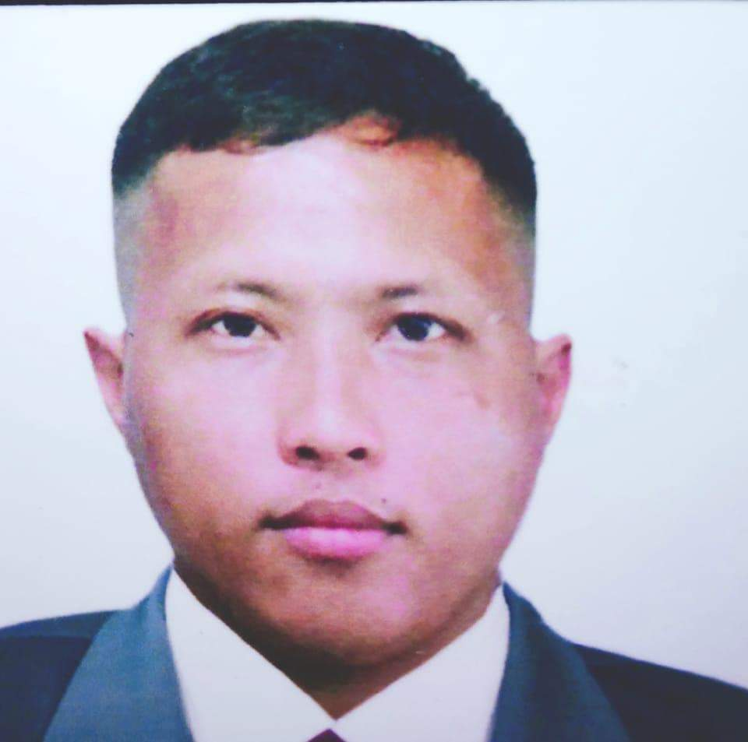

Rex L. Cagampang
Address: Purok 11, Brgy. Tuboran, Mawab, Davao de Oro, Philippines
Phone Number:+639351041443
Email: rexcagampang597@gmail.com
Nationality: Filipino
Date of Birth: November 13, 1987
Gender: Male

Objective:
To find a suitable, challenging and growth oriented position where I can best utilize my knowledge and full potential as a Butcher to a maximum level enabling me to contribute to the organization. To be able to improve knowledge, skills, and acquire experiences that would enrich more of my understanding in this field I have chosen to be one of the best.

Education:
Bachelor of Science in Secondary Education
North Davao Colleges
Davao del Norte 2005 - 2009
North Davao Academy
Davao de Oro 2001 - 2005
Tuburan Elementary School
Davao de Oro 1995 - 2001

Skills:
- Knowledge of animal anatomy.
- Knowledge of meat cutting and techniques.
- Ability to use knives and other cutting tools.
- Knowledge of food hygiene and safety requirements.
- Precision and physical strength.
- Ability to lift heavy equipment
- Knowledge in food processing and safety
- Good at communication
- Customer Service Oriented
- Ability to work long hours
- Ability to identify critical issues and respond quickly
- Compassionate care
- Work independently and collaboratively
- Empathy and Compassion
- Ability to carefully read and follow directions
- Flexibility in work duties and schedule
- Can Undergo Training

Experience:
Meat Cutter/Deboner - Tagum City Public Market
Jassele & JR Alvarez Meat Store October 7, 2019 up to Present
- Cleaned, trimmed, sliced, and section carcasses for future processing.
- Use a proper knife to debone pork and beef carcass.
- Obtained and distributed specified meat or carcass.
- Sanitizing used tools and equipment.
- Processed primal parts into cuts that are ready for retail use.
- Position pork/beef carcass to pull various parts off.
- Removed parts, such as skin, fur or bones, from the carcass.
- Cut pork/beef parts off and debone them on a line.
- Inspected meat products for defects, bruises, or blemishes and remove them along with any excess fat.
- Separate bone and skin to the body meat.
- Remove internal organs and clean it.
- Cut thighs,ribs,shoulder,neck and fats separate and hang the meat and deliver it to the client.
- Meats packing,and separate premium ribs and pork bones.
- Clean meat and slice it regularly to put the styrofoam then repack or cover plastic.
- Cuts up pork meat and beef meat for display.

I hereby certify that all of the information provided by me in this application is correct, accurate and complete to the best of my knowledge.

____________
Rex L. Cagampang

