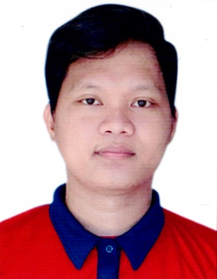
Abrahm Dave A. Tan
Samburon, Linamon, Lanao del Norte
Mobile Phone #: +639298092442
Email Address: abrahmdavetan@gmail.com

CAREER OBJECTIVE

To obtain a vital foundation in the field of this industry in my pursuance of an enduring career and self-gratification that will render my performance at its best for I am outfitted with academic knowledge, skills and experience which will eventually lead candidly to the company’s growth.

PERSONAL DATA

Address : Samburon, Linamon, Lanao del Norte
Age : 27 years old
Birthdate : April 20, 1996
Birthplace : Cagayan De Oro City
Sex : Male
Civil Status : Single
Religion : Roman Catholic
Dialect Spoken : Tagalog, Cebuano, English

EDUCATIONAL ATTAINMENT

TERTIARY
Name of School : Masters Technological Institute of Mindanao
MTIM Bldg., Fortaleza St. Cor De leon St., Poblacion, Iligan City
: College Level

Seminar/ Training Attended

Title: SLAUGHTERING OPERATIONS (SWINE) NC II
Date: March 27,2023- APRIL 30,2023

WORK EXPERIENCE
- ED MEATSHOP
DEBONER/MEAT CUTTER
DAVAO CITY, DAVAO DEL SUR, PHILIPPINES
February 5, 2018-Present

- Sharpen and fine-tune cutting tools
- Receiving, checking and stoning meat after delivery
- Slice, debone or ground the meat
- Display, weigh and wrap meat or meat products
- Meats are cut or prepared according to specifications or client request
- Rotate products to reduce the chance of meat spoiling, reduce waste and loss profits
- Ensure health and sanitation requirements, clean the tools and the workspace

SKILLS

Communication
Customer service
Problem-solving
Time management
Leadership

I hereby certify that all statements made in this resume are true and correct to the best of my knowledge.

Abrahm Dave A. Tan
Applicant

