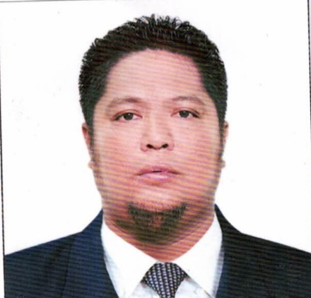
Mark Philip J. Arteta
3509 Catayauan, Lallo Cagayan Philippines
Cellphone# 09393194678
Marky.07071983@gmail.com

Personal information:
Date of birth: July 7,1983
Place of Birth: Catayauan, Lallo Cagayan
Citizenship: Filipino
Marital status: Married

Career objectives:
- An experienced medical technologist with a Bachelor’s degree in medical technology.
- having a for years working experience in clinical laboratory in the Philippines 2 years in Saudi and Kuwait and working here at Cataingan Medical Laboratory Center Corp. as Chief Medical Technologist up to present.
- excellent in clinical laboratory skills with commended performance conducting and analyzing laboratory assays resolving complex clinical and instrument problems.
- accurate, reliable, diligent and focused on timely quality completion of all laboratory procedures.
- contribute to improvement of quality, safety and cost of patient costumers and employee satisfaction.
- works well under pressure and time constraints with high volume environments.

Work experiences:
- February, 27 2021 up to present: CATAINGAN MEDICAL LABORATORY CENTER CORP.
- march 2019 to February 2020: AL SEEF HOSPITAL SALMIYA KUWAIT.
- September 2017- February 2018: NEW MOWASAT HOSPITAL SALMIYA KUWAIT.
- august 2014 to September 2016: ALMOWASAT HOSPITAL RIYADH K.S.A.
- 2012- to2014: rendered service in the local government of lal-lo as volunteer laboratory medical technologist.

Licenses and examinations:
March 2010: Professional regulation commission Registered Medical Technologist
Registration number: 0055166
September 2018: Passed Kuwait licensure examination for Medical Laboratory Technician.
August 2014: Passed Medical Laboratory Technician examination Saudi Health Commission for Health Specialties.
Registration number: 14-K-T-003637

Key contributions:
- executed and analyzed test in areas including chemistry, hematology, urinalysis, bacteriology, serology and immunology and blood banking to aid physicians in diagnosing and treating of disease.
- consistently commended for time high quality completion of both routine and special laboratory assays of patient’s specimen. (including blood, and other body fluids, skin scrapings and surgical specimens.)
- ensured test result validity before recording and reporting results, earning a reputation for meticulous attention to details.
- demonstrated the ability to communicate test results effectively with physicians, pathologist, and nursing staff and as a member of interdisciplinary team focus on providing exemplary quality of cares.
- trouble shoots simple system and mechanical failure.
- perform clerical error and support services as needed. Such as typing of official result, answering the telephone, calling STATS and reporting critical results to the appropriate departments or clinicians, disposing all contaminated specimens, controls of inventory, etc.
-evaluated quality control within the laboratory using standard laboratory test and measurement controls. And maintained compliance with CLIA, OSHA SAFETY and risk management guidelines.

Clinical trainings:
- Completed 12 months of training program rotating to all laboratory sections in two different hospitals.
- Conducted chemical analysis of blood, urine and other body fluids under a supervision of a staff medical technologist.
- Studied blood cells and other tissues to determine their relation to various physiological and pathological conditions.
- Performed proper specimen collection of blood and phlebotomy with proper aseptic technique.
- Performed clerical service (logging and typing of results, answering phone calls for inquiries, etc.
- Kept and record patients results in logbook in orderly manner.
Enhance interpersonal skills with courtesy and respect in interacting to medical staff and personnel in the hospital and with the patients.

INTERNSHIP HOSPITALS ATTENDE:
- PASAY CITY GENERAL HOSPITAL
Libertad Pasay City Philippines
April 2006 – October 2006

- SAN LAZARO HOSPITAL
Sta. Cruz manila Philippines
October 2006- Marc 2017

- Academic Background:
Centro Escolar University
BS. MEDICAL TECHNOLOGIST
JUNE 2000- 2006

Additional Information:
- Strong leadership
- Good interpersonal skills relationship and communication skills.
- Loyal, honest, diligent, determined, energetic and optimistic.
- Highly motivated, hardworking, cooperative and team player.
- Computer literate
- Speak and write English, Filipino, Ilocano, Ibanag, Visaya, and basic Arabic language.
- Knowledge in laboratory instruments and hi tech laboratory machine.
- Available for all work shift and extended hours.

CHARACTER REFERRENCES:
Miss Aileen C. Duano
Laboratory Manager/ President
CATAINGAN MEDICAL LABORATORY CENTER CORP.
Mobile #: +63917 1548097
Mr. Ralph C. Cabataña
Laboratory Chairman
CATAINGAN MEDICAL LABORATORY CENTER CORP.
Mobile #: +639275088722
Mrs. Glair C. Balanza
HR. Manager
CATAINGAN MEDICAL LABORATORY CENTER CORP.
Mobile #: +639175874480

