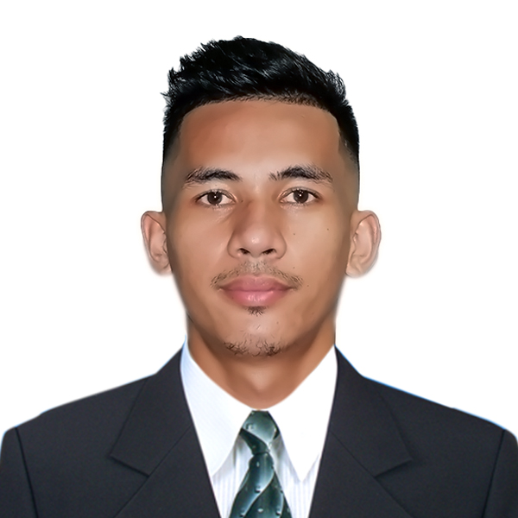

NOLEMER JR. TANTOY ESPAÑA
Purok 6, Poblacion, Laak, Davao de Oro, Philippines
Contact number: +639515549340
Email Address: nolimerespana@gmail.com
Objective:
To find a suitable, challenging and growth-oriented position where I can best utilize my knowledge and full potential as a Slaughterer/Butcher to a maximum level enabling me to contribute to the organization. To be able to improve my knowledge, skills, and acquire experiences that would enrich more of my understanding in this field I have chosen to be one of the best.
Personal Background:
Age : 25 years old
Date of Birth : April 2, 1998
Gender : Male
Height : 5’9
Weight : 65 kls.
Nationality : Filipino
Are you a left/right handed: Right handed
Passport No. :P3691848C (Valid until March,24 2033)
Civil Status : Single
Contact person in case of emergency: Mercedita Tantoy España
Contact no. : +639618603459
Education:
SECONDARY :Laak National High School
Poblacion Laak Davao de Oro
2013-2017
PRIMARY :Laak Central Elementary School
Poblacion Laak Davao de Oro
2007-2013
Training Certificate:
- Industrial / Retail Butcher/ Meat Cutting Deboning Training Program
Date:January 2019
Training Center: LAVCO – Luchay Agri Ventures Corpotion

- Occupational Health and Safe Procedure
LAVCO, 2019

- Good Manufacturing Practices/Food Handlers Seminaer
LAVCO, 2019

Experience:
Position- Butcher – LAVCO (Luchay Agri Ventures Corporation)
Date Employed : January,29 2019 up to Present
Company Name : LUCHAY AGRI-VENTURES CORPORATION
Address :Blk.8 Purok Lourdes St. Carmelite Rd. Bajada, Davao City
Name of Owner : Luchay Limlao
Contact No. : +639175490068

Job Description:
- Cutting and preparing meats for sale.
- Cleaning and maintaining tools and equipment and ensuring displays and signage are accurate and attractive.
- Weighing, packaging, pricing, and displaying products.
- Performing quality inspections on meats and other products.
- Negotiating and confirming orders with suppliers.
- Adhering to food safety and sanitation controls.
- Greeting and speaking to customers, providing advice, answering questions, and accepting orders or payments.
- Coordinating deliveries or order pickups.
- Duty hours from 1pm-8pm (from Monday-Sunday)

Position – Delivery Rider – (Elisabeth Cakes and Pastries Shop)
Date Employed : June 2018 – December 2018
Company Name : Elisabeth Cakes and Pastries Shop
Address: Purok 6 Poblacion Laak Davao De Oro
Name of Owner: Kathrine Joyce S. Cruda
Contact No. +639657823938

Job Description:
- Loading,Transporting and Delivering items to client in a
Safe and timely manner

Position – Field Sales Representative – (Rusi Philippines)
Date Employed : August 2017-March 2018
Company Name: Rusi Philippines
Address : Purok 1 Poblacion Laak Davao De Oro
Name of Owner: Ruel Taguro
Contact No. +639633095239

Job Description:
- Does Field Sales Work
- Responsible in maintaining our clients satisfaction (Before and after sales) during field visits
Skills and Capabilities:
- Ability to use hand tools and work in cold environments.
- Knowledge of meat preparation techniques and cuts.
- Ability to stand and work long hours
- Computer Literate MS Office
- Customer Service Oriented
- Ability to work long hours in location
- Strong Organizational and Time Management Skills
- Good at Communication
- Work independently and collaboratively
- Empathy and Compassion
- Ability to carefully read and follow directions
- Flexible in work duties and schedule
- Easily adjusts to different work environments and shifts
References:

Name : MS.LUCHAY LIMLAO
Position :Owner/City Councilor of Municipality of Laak
Company Name:Luchay Agri Traders Corporation
Company Address :Blk.8 Purok Lourdes St. Carmilite Rd, Bajada, Davao City
Contact No.:+639175490068

Name: MR.ROMAN NICOLO MONDEJAR Name : MR.JEFFREY ELCANA
Position: Human Resources Manager Postion: Head Butcher
Contact No.+639659135460 Contact No.+639811244122

I hereby certify that the information mentioned above are true and correct to the best of my knowledge and belief.

NOLEMER JR. TANTOY ESPAÑA

Applicant

