ARMANDO B. AQUINO |  |  |  |  |  |  | 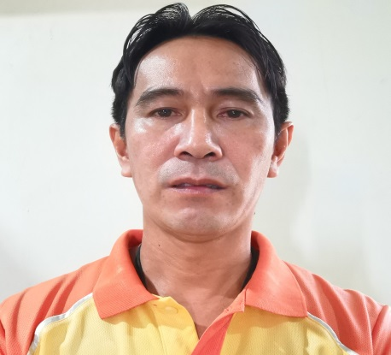
212 Visal San Pablo
Candaba Pampanga, Philippines
Contact No : +63-917-637 3014
email : aaquinoree@gmail.com
EDUCATIONAL ATTAINMENT
YEAR |  |  | SCHOOL / UNIVERSITY |  |  |  | DEGREE
1991 - 2004 |  | Rizal Technological University |  |  |  |  | • Bachelor of Science in Electrical Engineering
 |  |  | Boni. Ave. Mandaluyong City |  |  |  | • Registered Electrical Engineer
 |  |  |  |  |  |  | • Registered Master Electrician
2013 |  |  | MICROCADD |  |  |  | • Basic AutoCAD 2013/2014 with rendernig
1990 |  |  | National Manpower and Youth Council (TESDA) |  |  |  | • 3rd Class Ref. and Aircon Technician
 |  |  | Pasig City
1986 - 1990 |  | Bahay Pare High School |  |  |  |  | High School
 |  |  | Bahay Pare Candaba Pampanga
1980 - 1986 |  | Pulong Plazan Elementary School |  |  |  |  | Elementary
 |  |  | Pulong Plazan Candaba Pampanga
EMPLOYMENT
PERIOD |  |  |  |  | POSITION / COMPANY |  | DUTIES & REPONSIBILITIES
February 1, 2022 - To Present |  |  |  |  | Feedmill Supervisor A and L Fishpond and Hatchery Inc. |  | • Tending Supervision of Plant machine, maintenance operation. • Production of fish feeds. • Pelletmill Operator.
May 15, 2015 - January 31, 2022 |  |  |  |  | Maintenance Supervisor/PCO Texicon Agri Ventures Corporation |  | • Tending Supervision of Plant and machine, maintenance (EXTRUSION and PELLET MILL). • Pollution Control Officer • Production Supervisor Aquatic and Poultry feedmill plantm when needed.
December 20, 2009 - May 14, 2015 |  |  |  |  | Head, Electrical Department Danway Processing Corporation |  | • Tending supervision of Plant processes, Warehousing, logistics, raw materials receiving Machine operation and maintenance. Including Pellet Mill operation. • Control Operator
February 28, 2008 - Dec. 20, 2009 |  |  |  |  | Electrical Supervisor, Danway Processing Corporation |  | • Tending supervision, construction, erection of 20Tons per hour animal feedmill plant (Chiatung 20tph)
 |  |  |  |  |  |  | • Supervision construction, concreting of perimeter.
April 18, 2007 - August 18, 2007 |  |  |  |  | Building Admin Supervisor |  | • Resident Engineer.
 |  |  |  |  | Super SM Inc. (SM HYPERMARKET) |  | • Key custodian.
May 16 - Oct 31 2005 |  |  |  |  | Lineman Supervisor - Tagaytay Cable TV |  | • Surveying possible customers for expansion, estimate materials to be use.
 |  |  |  |  |  |  | • Assign day-to-day task to field personnel, Handles customer complain.
 |  |  |  |  |  |  | • Schedule preventive maintenance work for equipment.
 |  |  |  |  |  |  | • Installer of Dream Cable Satellite disc.
1994 - 2003 |  |  |  |  | Admin. Supplies Clerk -SM Supermarket |  | • Operate and maintain airconditioning units at Super Sale Club.
 |  |  |  |  |  |  | Supervise preventive maintenace.
 |  |  |  |  |  |  | • Operate and maintain 2 units Cat.Monark standby gen.set. 500 KVA and supervise preventive maintenance.
 |  |  |  |  |  |  | • Building and store maintenance: Ensure that the structure of the store premises is in good condition and the equiptments are properly utilized. i.e forklift, elevator, carts and computers.
 |  |  |  |  |  |  | • Plumber
 |  |  |  |  |  |  | • Do trouble shooting and repair during emergencies for the following equiptment: Aircon units, generator, Walk in freezer/chiller, forklift, UPS, printers and POS.
 |  |  |  |  |  |  | • Fixed asset and Supplies:Custodian of fixed asset and supplies (Inventory and Logistic). Issues supplies to all department and other branches.Replenish supplies stock. Provides monthly report to Admin Department, Branch Accounting and Branch Manager. Conduct yearly inventory of fixed asset and provides progress report. Prepares billing statement.
 |  |  |  |  |  |  | • Train new Supplies Clerk and Technical Crew (electrician).
 |  |  |  |  |  |  | • Assist other department during lean time.
1993 - 1994 |  |  |  |  | Bagger |  | • Assist customer, cashiers, co-baggers, stockman, customer service personnel.
 |  |  |  |  | SM Supermarket |  | • Utility Clerk to other deparment.
 |  |  |  |  |  |  | • Supplies clerk trainee.
TRAININGS ATTENDED
TRAINING |  |  |  | CONDUCTED BY |  | DATE | PLACE
Basic Pollution Control Officer |  |  |  | Pollution Control Association Of The Philippines |  | July 10 - 14 2017 | PCAPI OFFICE MANDALUYONG CITY
Basic Safety Training Course |  |  |  | Phil. Nautical Training Institue |  | May 29 - June 6, 2006 | MANILA
AFFILIATIONS
1. Regular Member- Integrated Institute of Electrical Engineers of the Philippines
2. Member - Pollution Control Association of the Philippines.
PERSONAL DATA
DATE OF BIRTH: September 22, 1973
PLACE OF BIRTH: CANDABA PAMPANGA PHILIPPINES
SEX: MALE
STATUS: MARRIED
HEIGHT/WEIGHT : 162 cm/ 70 Kgs
RELIGION: ROMAN CATHOLIC
SSS NO. 33-1739098-9
TAX ID NO. 157-075-555

