Sir,
Greetings!

I am Von Aldrich S. Reyes, 23 years of age, single a resident of Balbagon, Mambajao, Camiguin and in good health. A graduate of Bachelor of Science in Business Administration major in Human Resource Management at Camiguin Polytechnic State College last July 13, 2023.
I saw the posting of a job opening at your company on Facebook. I am writing to this letter to express my interest to apply on the said job.
I am physically fit to work in any division of assignment that I am qualified to enter. I can be easily trained as well as eager to work even under pressure or overtime.
Should this application merit your kind consideration and I would be willing to come for an interview at your most convenient time. My contact details as well as my qualifications are attached to this letter.

Anticipating for your favorable response. Thank you and God bless.

Respectfully,
VON ALDRICH S. REYES
Applicant

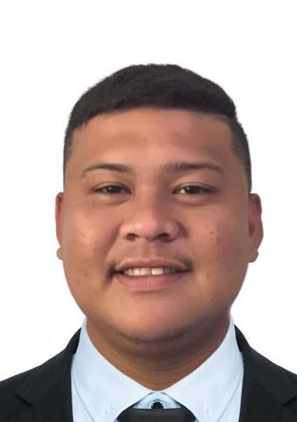
VON ALDRICH S. REYES
Balbagon, Mambajao, Camiguin
Contact No. 09811359165
E-mail Address: vonaldrich123@gmail.com

_______________________________________________

CAREER OBJECTIVE

To acquire valuable knowledge and skills to complement those that I have learned from school in an actual job environment. In return, I offer my service and determination to be an asset to your office throughout the duration of my training period.

PERSONAL INFORMATION
Nickname : Von
Gender : Male
Age : 23
Date of Birth : May 24,2000
Place of Birth : Cagayan De Oro
Civil Status : Single
Citizenship : Filipino
Height : 5’10
Weight : 90
Religion : Roman Catholic

Mother’s Name : Nanette S. Reyes
Father’s Name : Ricardo T. Reyes
Guardian : Ricardo T. Reyes
Occupation : Businessman

EDUCATIONAL BACKGROUND

Primary : Mambajao Central School, Poblacion, Mambajao, Camiguin
2011-2012

Secondary : Fatima College of Camiguin, Lumad, Poblacion, Mambajao, Camiguin,
2015-2016

Vocational : Science and Technology in Engineering and mathematics
Stem

Tertiary : Camiguin Polytechnic State College, Balbagon, Mambajao, Camiguin
2023

SKILLS

- Critical Thinking and problem solving
- Teamwork and collaboration
- Professionalism and strong work ethic
- Good communication skills
- Leadership
- Time and Multitasking
- Time Management
- Hardworking

REFERENCES

NAME | ADDRESS | CONTACT NUMBER
Jasper F. Mongaya | Balbagon, Mambajao, Camiguin | 09264563614

