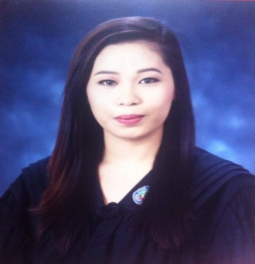

SUNSHINE T. MARAPAO
0182 Purok Matatag Brgy. Calios Sta. Cruz Laguna
Contact No.: 09127259391
Email: marapao0615@gmail.com

CAREER OBJECTIVES: To obtain a responsibilities and challenging job and opportunity where I could practice my knowledge and developed my personality as a career person while utilizing my skills and experience in order to establish career for the benefits of my employer.

PERSONAL DETAILS

Birthday: May 6, 1994
Birth Place: Fairview Quezon City
Age: 29 years old
Citizenship: Filipino
Status: Single
Gender: Female
Religion: Born Again Christian
Height: 5’6
Weight: 68 kl

KEY SKILLS:

- Self-Motivated and hard-working
- Have good written and communication skills
- Fast leaner and very much willing to learn new ideas
- Knows how to read and to write Stenography
- Customer service skill
- Have basic knowledge in Adobe Photoshop
  - Photo Editing
  - Invitation Cards (birthday, christening, wedding and flyers)
  - Certificates
- Computer Literate
- Microsoft Excel
- Microsoft PowerPoint
- Microsoft Access
- Microsoft Word

SEMINARS & TRAININGS ATTENDED

December 10, 2013 Competency – Based Development of
Office policies & Procedures
Laguna State Polytechnic University
Sta. Cruz Laguna

September 04, 201 Entrepreneurs Mind-set: Motivate To Innovate Laguna State Polytechnic University
Sta. Cruz Laguna

September 16, 2015 Leadership and Management Service
Laguna State Polytechnic University
Sta. Cruz Laguna

EDUCATIONS:
Tertiary
Laguna State Polytechnic University
Sta. Cruz Main Campus
Sta. Cruz, Laguna
Graduate: 2016
(Associate in Office Administration)

Secondary Education
Bagong Silangan High School
Fairview, Quezon City
Year graduated: 2010

Elementary Education
Bagong Silangan Elementary School
Fairview, Quezon City
Year graduated: 2006

ON THE JOB TRAINING
300 hours On the Job Training at the
Office of Cong. Benjamin C. Agarao Jr.
4th district Representative
Patimbao Sta. Cruz Laguna

WORK EXPERIENCE

MANG INASAL SANTA CRUZ BAYAN
Administrative Crew
JUNE 2016 to PRESENT

CHARACTER REFERENCES

MS. ROSE ANN SABADO
Restaurant Manager
Mang Inasal Restaurant Sta. Cruz Laguna
09480847930

MS. CRISTEEN GAYE CABRERA
ASSISTANT RESTAURANT MANAGER
Mang Inasal Restaurant Sta. Cruz Laguna
09053930796

I hereby certify that the above information is true and correct to the best of my knowledge and beliefs.

Sunshine Marapao
Applicant

