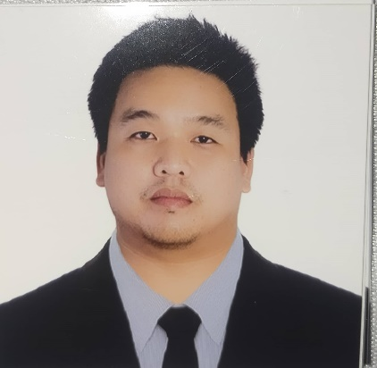
Ronilo Beltran Lopez
Concepcion Lubao Pampanga
0920-719-7628
lopezronilo21@gmail.com

Objective
Seeking a challenging career with a progressive organization that provides an opportunity to utilize my skills, talents and knowledge.

Duties & Responsibilities

- Repair bus engines such as Daewoo, Hino, Hyundai, Man18.350, Nissan, Volvo, Izusu etc.
- Trouble shooting in engines, brakes system, clutch system, and a little knowledge in electrical system.
- Evaluate and disassembled engines while examining auto parts for damage or excessive wear and tear.
- Inspect brake systems, steering mechanisms, wheel bearings, and other important parts to ensure that they are in proper operating condition.
- Listing of orders for engine or under chassis parts need for replacement.
- Maintained records of maintenance performed and submitted to the appropriate personnel.
- Delivered the necessary maintenance for diesel engines.
- Diagnose diesel engine and other vehicle functionality issues.
- Prepare appropriate recommendations to the supervisor regarding case status and disposition of the vehicle.
10.Recognized the need to replace of faulty parts of a
variety of make and models of vehicles.
- Provided preventative maintenance, according to the specified standards.
- Repaired and replaced engine, electrical, fuel, brake and exhaust repairs and performed emergency roadside services.
- Regulated the batteries by charging and fixing any defects.
- Provided service to unscheduled maintenance as well according to the need to check on vehicle.
- Document inspection and test results and work performed or to be performed.
- Inspect brake systems, steering mechanisms, wheel bearings, and other important parts to ensure that they are in proper operating condition.
- Adjust and reline brakes, align wheels, tighten bolts and screws, and reassemble equipment.
- Raise trucks, buses, and heavy parts or equipment using hydraulic jacks or hoists.
- Monitor and adjust the flow of oil, water or gases in a reactor as well as the weld processes and adjust as necessary, to avoid overheating parts.
- Check fuel levels in the engine and performed maintenance on all equipment, including gas and electric levels in the fuel pumps t ensured that all required maintenance procedures were followed.
22.Ensure cleanliness and safety of the area at all times

Field Service experience:
- Service due to engine overheat, replace defective water pump, water leak at hoses or radiator.
- Service due to blow-out tire, flat tire.
- Service due to clutch system failure, replace clutch booster, clutch master or clutch sliding
- Service due to electrical problem, alternator bearing noisy, not charging, or over charging.
- Service due to defective turbo charger/replace
6.Workshop experience (works performed)
- Service air leak trouble/replace air compressor head gasket defective
- Check or replace brake linings or brake pads, service on spring pin, king pin or bushings.
- Full out defective transmission, worn out clutch lining and defective clutch pressure
- Full out radiator if it is leak or clogged.

Brand and Model Serviced:
MAN 18.350
Yutong
Higer
Hino jo8c
Nissan Pf6
Nissan PE6
Nissan fe6
Man 18.360
Volvo br7
Hyundai D6ab, D6ac, D6ca, D6cb
Daewoo

•Maintenance Seminar Attended
•Daewoo Bus Mechanic Seminar (Columbian Manufacturing Corporation)
-July 27, 2016
-Rizal Avenue Extension, Caloocan City

•Bearing Basic and Maintenance Seminar (NSK International (Singapore) Philippine Representative Office)
-March 24, 2017
-Rizal Avenue Extension, Caloocan City

Educational Background
Tertiary
•Trade Technical Education (Pure Vocational) Major in Technical Automotive •Don Honorio Ventura Technological State University, Bacolor Pampanga •2010-2012
Secondary
•San Vicente High School •2004-2008
Primary
•Rizal Elementary School •1996-2003

Work Experience
May 2013 to present
Bus Mechanic / Truck Mechanic
Victory Liner Incorporated
Caloocan City, Metro Manila

Personal Data
Date of Birth: July 21, 1991
Place of Birth: Lubao, Pampanga
Age: 32 yrs. Old
Gender: Male
Height: 5’7
Weight: 90kls.
Civil Status: Married
Religion: Catholic

Character Reference

Name : Reynaldo Baa
Company : Victory Liner Inc.
Position : Chief Mechanic
Contact no.: 09178514024/vincerj311@gmail.com

Name : Carlos Semillano jr
Company : Victory Liner Inc.
Position : Service/Wrecker driver in Victory Liner
Contact no.: 09513181567/carlossemillanojr@gmail.com

I hereby certified that all information stated above is true and correct.

Ronilo Beltran Lopez
Applicant

