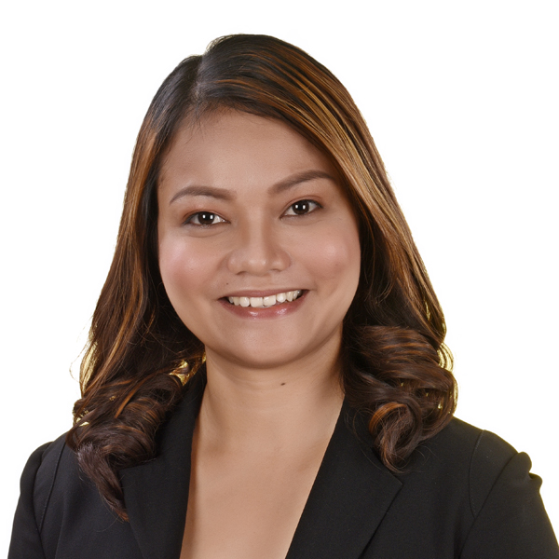 |  | Llanabelle O. laÑohan
Profile  Name : Llanabelle O. Lañohan  Age : 34  Birthdate : December 5, 1989  Birthplace : Sipalay City, Negros Occidental  Sex : Female  Civil Status : Single  Religion : Roman Catholic  Mother : Gemma Ortega  Lañohan  Father : Jose Done Lañohan  Address : BF Country Homes  Pajac, Lapu-Lapu City  Mobile number: 09291579671  E-mail Address: lanohanllanabelle@gmail.com |  | EDUCATION  Yoga Alliance  2021  Mindful Yoga Cebu School  Cebu Yacht Club, Mactan  Certified Aerial Yoga Teacher  Yoga Alliance  2018  Mindful Yoga Cebu School  Cebu Yacht Club, Mactan  Certified Vinyasa Yoga Teacher  Graduate School  2017 - ongoing  Cebu Technological University  Main Campus, R. Palma St. Cebu City  Doctor in Development Education  Graduate School  2011 - 2016  Cebu Technological University  Main Campus, R. Palma St. Cebu City  Master of Arts in Education Major in English Teaching  Tertiary  2006-2011  University of Cebu-Lapulapu and Mandaue  A.C. Cortes Ave. Looc Mandaue City  Bachelor of Secondary Education Major in English  Secondary  2002-2006  Cabarrus Catholic College  Brgy. San Jose, Sipalay City, Negros Occidental  Elementary  1996-2002  Binulig Elementary School  Brgy. San Jose, Sipalay City, Negros Occidental

EXPERIENCE:
Chilworks Learning Center  (Pre-School, Elementary & High School) | -manage day to day classroom activities, including structured lessons, free play, bathroom breaks, lunch time and rest time, and assist them in their other personal care  - create activities that are fun and educational for children  -develop and maintain a constructive and ongoing rapport with the children and parents | November 2010 – May 2013
University of Cebu Lapu-Lapu and Mandaue (College of Teacher Education & Gen. Ed) | - Prepares/updates/ submits Syllabi  - Conduct of classes (giving lectures on professional subjects for College of Teacher education, BEED, including Childhood and Adolescent Development, Facilitating Learning, Curriculum Development, Field Study, and Special Topics; and major subjects such as Children’s Literature, Language, and Speech Communication )  - Prepares and submits test  questions and Table of  Specifications (TOS) or alternative  assessment activities  - Involvement in Productivity Enhancement Program (Research and Community Extension) | June 2013- 2017
Cebu Technological University College of Teacher Education & College of Arts and Sciences) | Prepares/updates/ submits Syllabi  - Conduct of classes (giving lectures on professional subjects for College of Teacher education, BEED, including Childhood and Adolescent Development, Facilitating Learning, Curriculum Development, Field Study, and Special Topics; and major subjects such as Children’s Literature, Language, and Speech Communication)  - Prepares and submits test  questions and Table of  Specifications (TOS) or alternative  assessment activities  - Involvement in Productivity Enhancement Program (Research and Community Extension) | 2017- present

AFFILIATION:

PAFTE member
Glee Adviser
Alpha Harmonics (choir member)
Certified Yoga Instructor (under Yoga Alliance)

REFERENCE:

Dr. Geraldine Olmillo Education Program Specialist
09206985196

