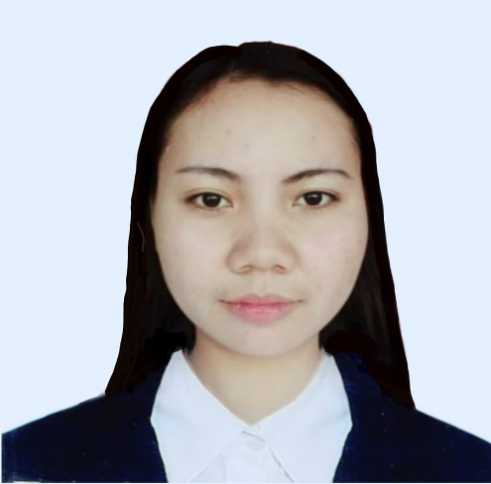
LORIE ANN D. ESTEVES
0953-634-5739
Reanne.dayag@gmail.com
OBJECTIVE
To apply the knowledge and skills that I obtain during my stay in school and my practicum to immerse my field of expertise. In return, I will offer my service and myself to be an asset to your company.
PERSONAL INFORMATION
Birthdate: June 21, 1999
Ages: 23
Civil Status: Single
Nationality: Filipino
Religion: Iglesia Ni Cristo
Address: Purok Namnama, Brgy. San felipe, SC of Munoz, Nueva Ecija, Central Luzon
Gender: Female

CONTACT INFORMATION
Mobile: 09536345739
Email: Reanne.dayag@gmail.com
Tagalog
English
EDUCATIONAL BACKGROUND
College: Bachelor of Arts in Psychology
Central Luzon State University
Science City of Munoz Nueva Ecija
2015- 2019

Secondary: Munoz National High School(Annex)
Science city of Munoz, Nueva Ecija
2011-2015

Primary: San Felipe Elementary School
Brgy. San Felipe, SCM. N. E
2005-2011

WORK AND TRAINING EXPERIENCE
Early Intervention Teacher
Big Steps Center for Special Education and child development
(Aug 2023- Present)

Behavioral Therapist
Shaping Milestone Learning Center (SMLC)
Abar 1st, San Jose City, Nueva Ecija
April 2022- April 2023

Virtual Sales Admin
Yeoubi Philippines
Apo St. Mabini homesite, Cabanatuan City,
(June 2020-July 2021)

SKILLS
Has basic computer literacy
Ability to comprehend and apply instructions with ease
Ability to work under- pressure
Willingness to learn
Good communication skills

REFERENCE
Ms. Bessi Mae Belza
College Instructor
Central Luzon State University
Science City of Munoz, Nueva Ecija
09052435608
Ms. Eleonor Paulino
Legal secretary
ABS-CBN
091777040461

