Emil Jason u. 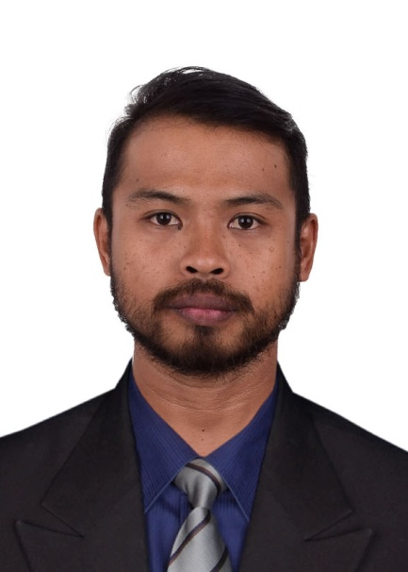Badana

+69152641729
emilbadana@gmail.com

SUMmary
A passionate and energetic line cook with exceptional food handling knowledge and the ability to multitask in a high-volume, fast-paced environment.

Experience

Line Cook 1 | April 2021 – July 2023
TIP Restobar
Responsible for preparing food including cleaning and cutting the ingredients and cooking the main dishes, desserts, appetizers and snacks.Ensuring that the kitchen operation procedures and hygiene meet food safety standards and regulations.

Global Talent Acquisition Specialist | June 2017 – August 2021
Career China
Responsible for identifying and engaging potential candidates through social media platforms and professional networks. Crafting recruiting emails, collaborate with hiring managers to determine requirements, and build talent pipelines.

Education
Bachelor of Arts in Political Science
University of San Carlos, Cebu Ph
Ship's Catering Service NC 1
Blue Horizon Maritime Training, Manila Ph

Skills
      - Has energy and drive
      - A sense of urgency
      - Motivating individual
      - Communicates clearly
      - Able to adapt in a fast-paced environment

Character reference
Jennilyn C. Rosales
VA Platinum
Financial Virtual Assistant
+639394558516
Rose LynnethPatromo
Career China
+639914767999
Liv Tanya Merina
TIP Restobar
+639178939295

