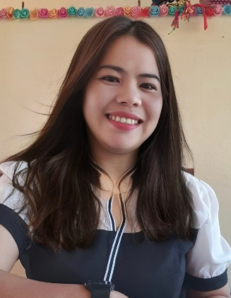
Diwata M. Melchor
Purok03
Aurora East, Diffun, Quirino
0995 134 1324
diwata.melchor001@deped.com

OBJECTIVE:

Position as Teacher

HIGHLIGHTS OF QUALIFICATIONS:

. Dependable and determined. I can work long hours.
. I have extreme patience that you can rely on and full of strength.

WORK HISTORY:

- Substitute Teacher I

Ammogaoen Primary School – October 2002-December 2002

Duties and Responsibilities:

- Responsible for teaching Grade I and Grade II class.

- Local School Board Teacher

Bikibik Primary School – June 2003-April 2005

Duties and Responsibilities:

- Responsible for teaching Grade I and Grade II class.

- Local School Board Teacher – June 2006-April 2010

Doña Imelda Elementary School

- Responsible for teaching Grade III Class

- Regular Teacher I

Doña Imelda Elementary School
- Responsible for teaching Grade V Cclass

- Regular Teacher III

Ricarte Sur Elementary School
- Responsible for teaching Grade V Class
- Responsible for Teaching Grade Two Class (2019-2024)

EDUCATIONAL BACKGROUND:

Doctoral Degree – Northeastern College, Santiago City
Undergraduate (with 24units)

Masteral’s Degree- Quirino State College
Master in Arts
June, 2013-April, 2016

College – Quirino State College
Bachelor in Elementary Education
June, 1996 - March, 2000

High School – Quirino State College
June, 1992 – March, 1996

Elementary – Diffun Central School
June, 1986 – March, 1992

TRAININGS:

Learning and Development Training Workshop on Project APCC
Lecture on School Paper Management
National Training/Seminar Workshop on Information Technology with PRC Accreditation
TINTALAS (Sharpening of the Pen) Gearing Up On Quality Campus Journalism for School Papers Advisers
District Results – Based Performance Management System (RPMS)
Mass Training of Grade VI Teachers on the K to 12 Basic Education Program
2-Day Seminar-Workshop in Reading for Grade II-VI Teachers and School Heads of Diffun
District Learning and Development Activity Along Developmentally Appropriate Practices in the Early Language Literacy and Numeracy
Enhancing Pedagogical Skills and Resources for Classroom, Music, Art, Physical Education and Health Teaching
Mass Training of Grade V Teachers on the K to 12 Basic Education Program
Diffun District 02 in Service Training

REFERENCES:

- Sandro M. Zamora – Public School District Supervisor
- Roger L. Patiocan – Elementary School Principal II

DIWATA M. MELCHOR

Applicant

RESUME

RESUME

RESUME

RESUME

