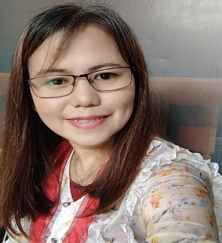
Diosabel M. Manubay
Purok04
Villa Ceferina, Sinsayon Santiago City
0917 127 1463
manubaydiosabel88@gmail.com

OBJECTIVE:

Any position that commensurate in my application

HIGHLIGHTS OF QUALIFICATIONS:

A highly experienced Pharmacy Assistant with 13 years of experience providing excellent costumer service and support. Skilled in filling prescriptions, counting and labeling items, and responding to patient questions regarding medications. Dedicated to providing the highest quality of care and ensuring costumer satisfaction.

SKILLS:

Goal Oriented
Team Player

WORK HISTORY:

1996-1999 Saleslady
Alialy’s School Supply and Merchandise
Diffun, Quirino

2004-2008 Pharmacy Assistant
RENMAR DRUG AND MEDICAL SUPPLY AND HOSPITAL
VILLASIS, SANTIAGO CITY
- Assisted pharmacist by filing prescriptions for customers and responding to patient questions regarding prescriptions and medication-specific issues.
- Greeted costumers and responded to questions with friendly knowledgeable assistance.
- Assisted the costumer to perform the medical supply on how they used it

2009-2018 Pharmacy Assistant
THE GENERICS PHARMACY
DUBINAN EAST, SANTIAGO CITY
- Counted and labeled prescription with correct item and quantity
- Assisted pharmacist by filing prescription for costumers and responding to patient’s question regarding prescription and medication.

EDUCATIONAL BACKGROUND:

College University of La Salette
Undergraduate
June, 1997- March, 1999

High School Saint Mary’s Academy
June, 1993 – March, 1997

Elementary Diffun Central School
June, 1987-March, 1993

REFERENCES:

- Dr. Renato Elefante Director
RENMAR DRUG AND MEDICAL SUPPLY
AND HOSPITAL
VILLASIS, SANTIAGO CITY
- Mr. Patrick Tan Yap Franchisee
THE GENERICS PHARMACY
DUBINAN EAST, SANTIAGO CITY

DIOSABEL M. MANUBAY

Applicant

RESUME

RESUME

RESUME

RESUME

