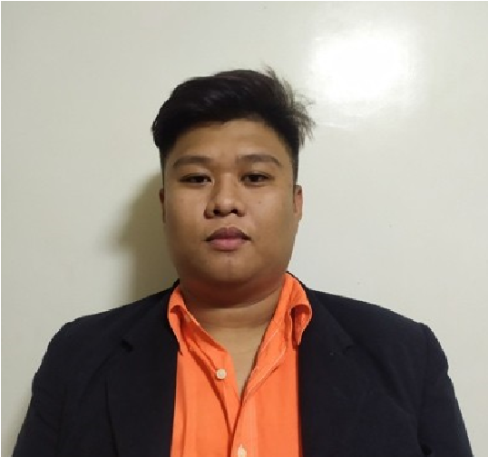
REINER JOHN CARBONEL BERBO
B44 L15 Barangay Yakal Silang Cavite
09696022410 / lmm.berbo@gmail.com

OBJECTIVE
Seeking a position in a dynamic organization where I can launch my career and work towards building a strong skill set. A hard working individual looking for a challenging position where I can showcase my skills and contribute to the growth of the organization.
SKILLS
- Proficient in Corel Draw
- Proficient in Adobe Photoshop
- Proficient in Adobe Illustrator
- Graphic Design for (Corrugated Boxes)
- Knowledge in Lathe machine and Milling machine
- Knowledge in AutoCAD
- Safety Officer 2 Certified
- Repair/Troubleshoot Basic Home Electrical
- Written and Oral Communication Skills
- Computer Literate (MS OFFICE)

PERSONAL QUALITIES:
- Positive Attitude towards work, honest, self-motivated and time devoed.
- Using knowledge and skill for the enhancement of human welfare and environment.
- Determined to improve my competence and quality of works.
EDUCATIONAL BACKGROUND:

TERTIARY:
Bachelor of Science in Industrial Technology (BSIT) Major in
Mechanical Technology
Rogationist College
Lalaan 2, Emilio Aguinaldo Hi way, Silang, Cavite Graduated - 2022
SECONDARY:
Child of Zion Academy Zone 11 Tatic Homes Graduated - 2015
ELEMENTARY:
Child of Zion Academy Zone 11 Tatic Homes Graduated - 2011
PERSONAL ATTRIBUTES:
Sex | : | Male
Date of Birth | : | July 9, 1999
Age | : | 24
Civil Status | : | Single
Nationality | : | Filipino
Religion | : | Catholic
Language | : | English, Filipino

REFERENCES:
Dr. Jhodelix Sarcilla
Dean - Ted/Engineering and Industrial Technology Department
Rogationist College
09478939803

Mhel Lachica
Product Developer/Printing Line leader
Taiphil Packaging Corp
09497745306

Rence Castroverde
ATPI Operations Admin
09150510620

Work Experience:
Present
Product Developer/Designer
Taiphil Packaging Corp.
July 2023 - Present

ATM Technician
Armored Transport Plus Inc.
July 2022 – April 2023

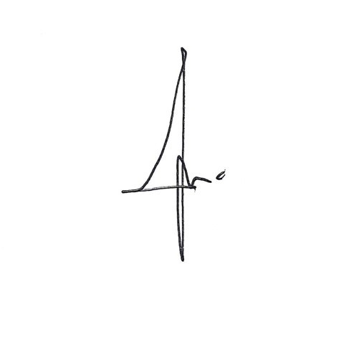
I hereby certify that that the above information is true.
Applicant

