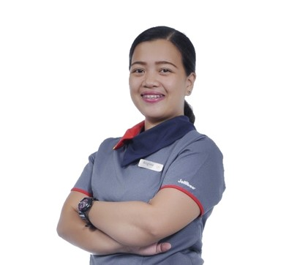
Regine May Oropesa
Address: 6895 Rue de Venus, Quebec City
Phone: 581-688-4492
Email: oropesaregine08@gmail.com
Skype or Zoom ID: 461 017 0039
Marital status: Common Law
Number of children: 2
Ages of children: 9yo &4yo
Birthdate: May 16, 1993

POSITION SOUGHT: Food Service Supervisor

SUMMARY OF QUALIFICATIONS

- 10 months on going experience as Food Service Supervisor in Mcdonalds, Quebec Canada
- 4.5 years experience Assistant Restaurant Manager in Jollibee Foods Corp.
- 3.5 years’ experience in payroll/time-keeping/recruitment.
- Thorough at maintaining the principles and procedure of public human resources administrations.
- Excellent communication and human relation skills.
- Hands on experienced increasing my abilities on a daily basis of learning new software easily.
- Honest ability to maintain confidentiality of work records.
- Ability to multi task in an ever-changing environment.
- Strong sense of responsibility and desire to get things done properly.
- Can work to tight deadlines.
- Ability to build relationships.
- Career-minded and professional at all times.
- My greatest asset is I am confident in my abilities to perform any positions you may have, after proper training, I will blend right in to the workforce.

WORK HISTORY

Shift Supervisor 05-2023 to Present
Les Restaurant Mika Inc. (Mcdonalds)
Quebec City, Canada
- Greet customers as they enter and thank them for their business as they leave.
- Ensure food safety standards are being followed
- Prepare food according to the store’s specifications
- Clean and maintain designated area during downtime

Database Specialist 04-2022 to 04-2023
PSG Global Solution
Makati City, Philippines
- Recommend and implement emerging database technologies.
- Create and manage database reports, visualizations, and dashboards.
- Create automation for repeating database tasks.
- Be available for on-call support as needed.

Assistant Restaurant Manager 04-2017 to 02-2022
Chanbee Food Corporation (Jollibee)
Paranaque City, Philippines
- Handled Sales and Training Management
- Coordinating daily restaurant management operations
- Delivering superior food and beverage service and maximizing customer satisfaction
- Responding efficiently and accurately to restaurant customer complaints
- Ensuring incoming staff complies with company policy
- Training staff to to follow restaurant procedure
- Maintaining safety and food quality standards
- Keeping customers happy and handling complaints
- Organizing schedules of crews/riders
- Adhere to and enforce employee compliance with health, safety, and sanitation standards

EDUCATION HISTORY

Bachelor of Science in Operations Management 2009-2013
Olivarez College, Philippines

TRAININGS

Food Safety Program 2021- 2023
Paranaque City, Philippines

REFERENCES
- Abegail Oropesa – HR Specialist
09950022385

