DIANNE JO MARCIAL CABANLIT

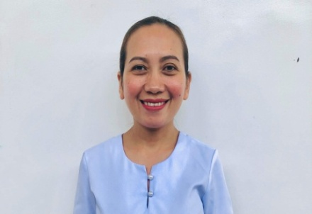
Address: Northern Poblacion, Calamba, Misamis Occidental
Contact #: 09760271429
Email: djcabanlit36@yahoo.com
Zoom ID: Dianne Jo Cabanlit
Marital Status: Married
Birthdate: May 10, 1983

POSITION SOUGHT:

- Nurse

SUMMARY OF QUALIFICATIONS

- Over 13 years of experience as a Registered Nurse
- with over 11 years experience in Calamba District Hospital (CDH), Philippines
- 2 years experience in Quality for Home Medical Care (QHMC) in the State of Qatar
- Strong background in leadership as promoted to Senior Emergency/Delivery Room Nurse
- Proven skills in problem-solving abilities in the assigned area in the hospital
- Demonstrated ability to active listening skills, communication and interpersonal skills
- Professional communication skills include fluency in English

WORK HISTORY
Nurse 1 December 1, 2021 - Present
Calamba District Hospital
Calamba, Misamis Occidental

- Worked as a Senior Nurse in Emergency and Delivery Room
- Treating critical injuries, allergic reactions, and trauma
- Displaying strong decision-making in emergency scenarios
- Provide patient-centered care to mother during labor and delivery of the baby

Staff Nurse November 10, 2019 - November 30, 2021
Calamba District Hospital
Calamba, Misamis Occidental

- Rehired in the said hospital as a Staff Nurse assigned in Geriatric Ward
- Involved planning and coordinating care of the Elderly with physical impairments to meet their long term care needs and improve their quality of life

Registered General Nurse September 15, 2017 - September 15, 2019
Quality for Home Medical Care
State of Qatar

- A Homecare Nurse with experiences in Elderly and Baby Care
- Worked as a Clinic Nurse assigned in Out-Patient Department with special areas in ENT, Pedriatric and General Surgery In Rayhan Medical Complex
- Handled Preschool Children in giving medicines as a School Nurse in Muaither Nursery
- Worked in the Royal Family as a Private Nurse in Wajba Palace

Staff Nurse August 23, 2010 - September 10, 2017
Calamba District Hospital
Calamba, Misamis Occidental

- Assigned in different areas on yearly rotation in Pediatric and Medical Wards
- Rendered nursing care in child patients, evaluating their symptoms and checking their vital signs
- Administered medications or minor procedures

EDUCATION HISTORY
Bachelor of Science in Medical Technology 2003-2005
Silliman University, Philippines

Bachelor of Science in Nursing 2005-2008
Dipolog Medical Center College Foundation Inc., Philippines

- RN - Registered Nurse, Philippines
License #: 0549836

- RGN - Registered General Nurse, State of Qatar
License #: N20538

TRAININGS
- BLS - Basic Life Support
Issuer: Red Cross
Calamba District Hospital, Philippines
- BLS (Basic Life Support) & ACLS (Advanced Cardiac Life Support) Trained
Hamad Medical Hospital, Qatar

- BLS - Basic Life Support
Issuer: American Heart Association
Ozamis City, Philippines

REFERRENCE:

- Dr. Nathaniel Lawrence Medina - Medical Doctor in Calamba District Hospital
Contact #: 09760271429
- Mrs. Arceviljill Pulvera - Chief Nurse in Calamba District Hospital
Contact #: 091931155923

