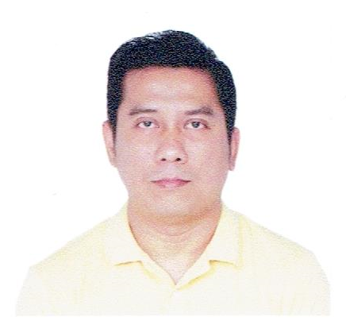 | Marlo Dayham Sonugan  olram69@yahoo.com  +639530628481  Present Address:  #143 PUROK 1 GUSA, Cagayan de Oro City 9000, Misamis Oriental, Philippines  Permanent Address:  Barangay Gusa CDO, Cagayan de Oro City 9000, Misamis Oriental, Philippines

Basic Information
Age  36 | Birth Date  Jul 05, 1987 | Gender  Male | Civil Status  Single
Height (cm)  162.6 | Weight (kg)  62 | Nationality  Filipino | Religion  Christianity - Catholic

Work Experience
Apr 2020 – May 2023 | Butcher  Kuya Chick-Boy Meat Shop  Retail / Merchandise  Purok 2 Phasco Village Tablon, Cagayan de Oro City  Cutting, grinding and preparing meats for sale. Cleaning and maintaining tools and equipment and ensuring displays and signage are accurate and attractive. Weighing, packaging, pricing, and displaying products. Keeping records, budgets, and inventory.
Aug 2017 - 2018 | Production Worker  Sanabel AL Salam Riyadh Saudi Arabia
Aug 2014 - Oct 2016 | Sales Man  EDB Staffing Services Incorporation  Manufacturing / Production  Cagayan De Ori City  Representatives sell retail products, goods and services to customers. Sales representatives work with customers to find what they want, create solutions and ensure a smooth sales process. Sales representatives will work to find new sales leads, through business directories, client referrals.
Feb 2011 - Jun 2012 | Personal Driver  UCPB SAVINGS BANK  Banking and Financial Services  Cagayan De Oro City  Performs work in the operation of a vehicle to assure safe transportation of clients to and from various destinations and to assist clients on entry and exit from vehicles as necessary.
Jun 2008 - Nov 2008 | Driver Crew  Big Flat Bread  Food & Beverage / Catering / Restaurant  Cagayan de Oro City  Making Pizza Delivery drivers have to deliver all the goods that are assigned to them and on time. They have to map out the fastest route to the desired destination. They have to make entries regarding the goods that they are delivering. They have to drive safely at all times and have to conduct inspections about their truck, whether it is in good condition, and if need be, they should also be able to repair it. them if there are any delays. They have to drive safely at all costs.

Educational Attainment
Oct 2018 - Mar 2019 | Sweet House Pastry School Inc.  Vocational Diploma / Short Course Certificate  Professional Baking and Pastry Arts
Jun 2006 - Jun 2007 | Xavier University Ateneo De Cagayan  College Level (Undergraduate)  Computer Technology

Licenses / Certifications
Dec 21, 2019 | National Certificate ll in Slaughtering Operations (SWINE)  1904302029837
Mar 02, 2019 | National Certificate II in Bread and Pastry Production  19104302003147
May 18, 2005 | 478 Hours Nursing Assistant
Apr 18, 2005 | Home For The Aged Foundation, Inc.
Mar 31, 2005 | Community Health Care Center

Government Documents
Passport | ID Number: P6463478A  Place of Issue: DFA Cagayan de Oro City  Date of Expiration: Mar 17, 2028

Trainings / Seminars
Jul 12, 2007 - PRESENT | FOODHANDLERS SEMINAR

Skills | drive | butchering | baking

Languages | English | Tagalog

Character References
Jeorgelyn E. Barlisan | Math and Science Teacher  Liceo de Cagayan University  09666606114  jebarlisan@liceo.edu.ph
Allen Adrian Tabaco taal | Meatshop Owner  Cagayan de oro City  +639758401992  artms@yahoo.com

