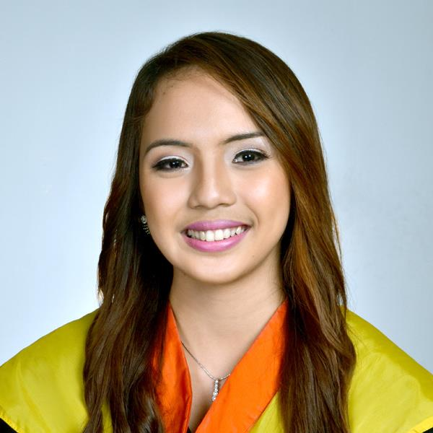
RITCHELLE MAE O. PABUTOY
Present Address: Dampas District Tagbilaran City
E-mail: rm.chelleey@gmail.com
Mobile No. 09471835689
PERSONAL INFORMATION:
Age : 31 years old
Date of Birth : November 13, 1992
Civil Status : Single
EDUCATIONAL BACKGROUND:
Primary : Holy Name University School Year : 1999-2005
Secondary : Holy Name University School Year : 2005-2009
College of Nursing Holy Name University School Year : 2009-2013
BS Education Qualifying Holy Name University Year: 2016
LICENSURE:
Licensed Professional Teacher
Registered Nurse
WORK EXPERIENCE:
Dra. Joanne Dental Clinic
Job description: Dental Nurse or Dental Assistant Date : January 2017- February 2018
- Performed high quality nursing while assisting the Dentist in a safe and effective manner.
- Established and maintained productive working relationship with all members of the dental team
- Keep accurate records and ensure the recording methods are used in line with agreed practice policy
- Ensured that the surgical areas and equipment are regularly cleaned and maintained.
- Assist at reception and perform other clerical duties if required.
Skin Perfection Body Contouring Salon and Spa
Job Description: Aesthetic Nurse Date : April 2018 – December 2018
- Work as part of a non-surgical team that provides the highest level of patient care.
- Practice independently on all non- surgical treatments in line with company policies and protocols.
- Doing laser procedures and consultations.
- Educating clients about treatments, services and offerings.
- Scheduled patient appointments and follow-up visits.
- Provided follow-up care instructions to patients.
- Recommend specific treatments needed by the clients and thoroughly explain the importance and benefits of the said treatment or procedure
- Prepares medicines for drip, decides appropriate treatment for the patients.
Department of Health
Job Description: Covid Nurse Date: May 2021 - December 2021
- Assessed patients’ condition, notified physicians of clinical changes as well as prepared and implemented patient care plans.
- Monitored vital signs, adequacy of ventilation, and levels of consciousness and pain.
- Administered medications as determined by the patient’s condition (IV, Sub-Q, etc.)
- Communicated the patient’s condition to family members in a compassionate and non-technical manner.

Shearwater Health Inc.
Job Description: Medical Transcriptionist Date: January 2019 – present
- Provide patient clinical information and review medical records
- Conduct inbound/outbound/outreach to providers; escalate calls; provide clinical patient information, arrange admissions, transfers and consults and to make call back arrangements; task, prioritize and confirm the arrangements and provide 3-way conferencing. All of which are to be provided in a manner of the individual Providers’ choosing, such as telephonic, email, page, text and web.

REFERENCE:
Dra. Joanne Flores – Dentist Phone no. 09194030520
Carmina Diaz – Skin Perfection Supervisor no. 032-2540725
Shearwater Health Inc. – (02)7756-4222

