Personal details
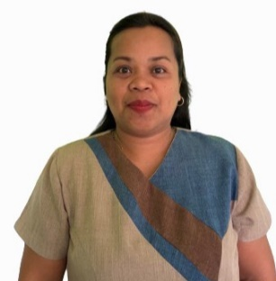
Name Daphny Precy C. Villamor
Place and Date of Birth Hernani, Eastern Samar 6804, 20th January 1984
Sex Female
Address Brgy. Canciledes, Hernani, Eastern Samar 6804
Marital Status Married
Contact Number 09066674245
Email dvillamor982@yahoo.com
  - EDUCATION

- March 2015 Master of Arts in Education at Asian Development Foundation College
Major Educational Management
Units Earned CAR Holder + 9 units
- 2003 Graduated College Bachelor of Elementary Education at Eastern
Samar State University (Borongan City)
Major Mathematics
- 1999 Graduated Secondary Highschool at Hernani National High School
- 1995 Graduated Primary School at Hernani Central Elementary School

SKILLS

- Microsoft Office
- Internet Literacy

WORKING EXPERIENCE
- 2021 – Present Teacher In Charge at San Isidro Elementary School, Hernani District
- 2018 – December 2021 Elementary Grade Teacher III at San Isidro Elementary School
- 2009 – March 2018 Elementary Grade Teacher I at San Isidro Elementary School

