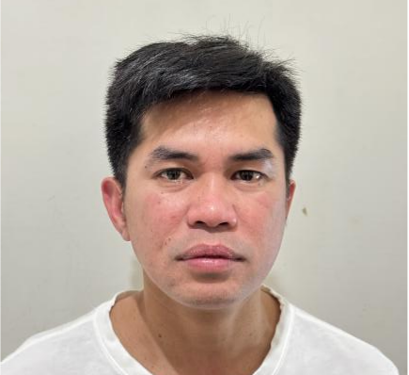

EDDIE B. SUAN JR
Address: No. 136 Gongyi Rd. Zhunan Township, Miaoli County, Taiwan R.O.C
Contact Number: 0932762942
Email Address: 84eddiesuan@gmail.com
Career Objective:
To pursue a career in an organization where I can utilize my skills and knowledge for advancement of the company. Providing friendly and professional service.

PERSONAL INFORMATION
Gender : Male
Age : 39 years old
Date of Birth : June 6, 1984
Citizenship : Filipino

Height : 163 cm
Weight : 58 kg
Religion : Roman Catholic
Civil Status : Single

EDUCATIONAL BACKGROUND

Tertiary Education: UNIVERSITY OF MINDANAO( Davao City, Philippines)

Bachelor of Science in Mechanical Engineering

Examination Taken: Board of Mechanical Engineers Philippine Regulatory Commission(PRC)

Remarks: passed ( Registered Mechanical Engineer ) April 2008

WORK EXPERIENCE:

GREATEK ELECTRONICS INC. (TAIWAN) ( 2021 up to present)
Final Testing ( Set-up/Maintain Engineer)
KING YUAN ELECTROINICS COMPANY (TAIWAN)( 2018-2021)
Final Testing (Maintain Engineer)
RIYADH CABLE GROUP OF COMPANIES (Riyadh KSA)(2016-2017)
Copper Plant( Mechanical Technician)
INTERNATIONAL PIPE INDUSTRIES CORP. (PHILIPPINES)(2008-2016)
Quality Assurance/Quality Control

EDDIE B. SUAN JR
Applicant

