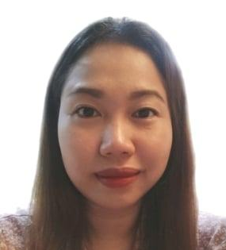
SAN ISIDRO ELEMENTARY SCHOOL | 2023–Present

Teacher I
City Schools Division Office in Antipolo

Tasks:
      - Planned, prepared and implemented weekly lesson plan.
      - Built and maintained positive classroom culture.
      - Daily communicate with parents or guardians to increase motivation in learning to suit child needs.
      - Supervised students in a nurturing and family-like environment classroom.
      - Developed learning materials that engaging students to solve, experiments, and inspires to learn.

Pauline Learning Center Inc. | 2018 – 2020

Kindergarten and Elementary Teacher
Cainta Rizal

Tasks:
      - Monitor student’s interactions, performance, and progress to ensure the mastery of skills.
      - Tailor variety of approaches and materials appropriate to the student needs.
      - Keep lessons interesting and engaging
      - Integrated play-based, arts, and music to impart learning and social skills.
      - Create a positive and implement a suitable classroom management.
      - Establish and enforce classroom rules to maintain order among students.

WORK EXPERIENCE

MARITES SALILING

LICENSED PROFESSIONAL TEACHER

ABOUT ME

Certified Licensed Professional Teacher with 5 years of teaching experience. Compassionate and caring in building connections to students to foster their growth and development. Seeking to leverage educator skills to contribute to the emotional and healthy mental development of a child.

SKILLS




2019-Present | Antipolo City- Philippines

Post Graduate

Master of Arts in Education major in Educational Management
Our Lady of Fatima University

2018 | Antipolo City - Philippines

Bachelor of Elementary Education major In Early Childhood
Our Lady of Fatima University

EDUCATION
SEMINARS AND TRAININGS
- Virtual training of 2023 Division Women’s Month Celebration and Culminating Activity held on March 15-16 2023.
- CSDO ANTIPOLO OK SA DEPED 2021 CELEBRATION AND WEBINAR SERIES held on September 27, 2021

ACHIEVEMENTS
- School Dental Coordinator (2021-Present)
- Active member of school-based Wash-in-School (Wins) (2021-Present)
+63 977 108 5264

marites.saliling@deped.gov.ph

Antipolo City, Philippine

Darryl Alcones
Teacher II
Mayamot Elementary School
09560662417

Jakilin T. Iringan
Master Teacher I
Dela Paz Elementary School
09064158942

Lourdes Ramos
Teacher I
Canumay Elementary School
09950393547

REFERENCES
CONTACT
- Planning and Organizing
- Communication with Parents
- Positive Discipline
- Child Safety
- Classroom Management
- Problem Solving
- Lesson Plan Creation
- Knowledgeable in using Microsoft Office
- Teamwork
- Patience and Empathetic
- Adaptability and Flexibility

©AZURIUS - My-resume-templates.com

