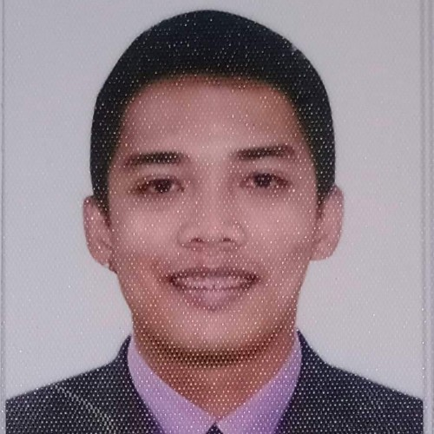
HELMARK R. AGTARAP
Cabisera 14-16 (Casilagan) City of Ilagan, Isabela
Contact No: 09984286686
Email Address: magtarap73@gmail.com

OBJECTIVE:
To obtain a challenging position and to work for the company’s that eventually help to develop my skills, knowledge and abilities. Find a job opportunity where I can put my training and abilities to good use while contributing the company’s success.

QUALIFICATION AND SKILLS:
- Flexible to different situation
- Ability to work under pressure
- Fast learner
- Self- motivation
- Can work independently and as a team

CAREER OBJECTIVES:
- To use my skills in the best possible way for achieving the company’s goals.
- To build for myself a long-term career in working in your company that has the potential for great growth and development.

EDUCATIONAL BACKGROUND:

ELEMENTARY: Casilagan Elementary School
Cabisera 14-16 (Casilagan) City of Ilagan, Isabela
2009-2010
SECONDARY: Saint Ferdianand College
Sta. Ana Street, Bagumbayan City of Ilagan, Isabela
2017-2018

TERTIARY: Isabela State University- Ilagan Campus
Bachelor of Science in Industrial Technology- Major in Automotive
Calamagui 2nd City of Ilagan, Isabela
June 2018- April 2019 (Undergrad)

TRAININGS AND SEMINARS ATTENDED:

13th Regional Hospitality and Tourism Convention
Crown Pavilion, Tuguegarao City, Cagayan
September 16, 2016

Cruise Ship Convention 2017 Food Sanitation and Hygiene (HACCP)
Romulo Hall, Teacher Camp, Baguio City
February 18, 2017

Manpower Skills Training Program 2022 (NC II- Organic Agriculture Program)
Rang-ayan, City of Ilagan, Isabela
Feb 20, 2022 valid until February 19, 2027

Slaughtering Operation (Swine) NC II
La Union Naguillian, Slaughtering house
June 6, 2023- July 6, 2023

International English Language Testing System (IELTS)
September 23, 2023
Test results (Listening 4.5), (Reading 3.5), (Writing 5.0) and (Speaking 5.5)
Overall band score 4.5

WORKING EXPERIENCE:
Esteban Meatshop- New Ilagan Public Market Baligatan
City of Ilagan, Isabela
June 04, 2019 up to present
As butcher/slaughter

- Prepare and Sharpen Knives
- Restraining
- Stunning
- Shacking
- Lifting
- Sticking
- Scalding
- Dehairing
- Secondary dehairing
- Hooves removal
- Expose Tendons
- Gambrelling
- Singeing
- Open Chest bone
- De-bung
- Remove Sex Organ
- Evisceration
- Offal Inspection
- Splitting
- Final wash
- Grading
- Branding
- Weighing
- Chilling

PERSONAL INFORMATION:
Date of Birth: November 27, 1996
Place or Birth: Cabisera 14-16 (Casilagan) City of Ilagan, Isabela
Age: 27
Height: 5’6
Weight: 57 kgs
Civil Status: Single
Religion: Roman Catholic
Nationality: Filipino
Language: Tagalog, English, Ilocano
Father’s Name: Benjamin Agtarap
Occupation: Farmer
Mother’s Name: Rebecca Agtarap
Occupation: Housewife
References:
Joel B. Esteban
Manager, Esteban Meatshop New Ilagan Public Market Baligatan
0977-209-4488
City of Ilagan, Isabela

I hereby certify the above information are true and correct to the best of my knowledge.

Helmark R. Agtarap
Signature

