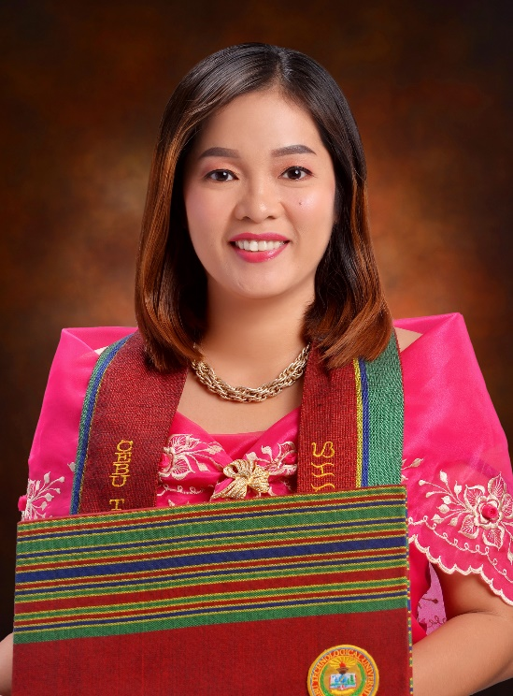

Summary
A Public Elementary teacher in the Philippines with 14 years of teaching experience. A hardworking and passionate teacher to children. Willing to learn and explore teaching opportunities

Experience
Elementary Teacher – 06/2015- present
Lagtang Elementary School- Lagtang, Talisay City, Cebu
- A motivated teacher handling Grade Six pupils.
- A public Elementary Teacher for 14 years
- Graduated Bachelor in Elementary Education major in English
- Teaching Science subject.
- Science Coordinator for 3 years at Lagtang Elementary School

Elementary Teacher- 06/2009 to 03/2015
Iba Elementary School-Iba, Talisay City, Cebu

- A teacher of a combination class of grade 1 and garde 2 learners.

Education
- Master of Arts in Education: Supervision and Administration – 2023
Cebu Technological University, Cebu City
- Bachelor in Elementary Education major English 2006
Misamis University, Misamis Occidental, Philippines
- Secondary Education -2001
Ozamiz City National High School
Ozamiz City, Misamis Occidental, Philippines

Trainings and Seminars

- Division Training on Science Investigatory Project 2023
- Gender and Development Training 2022
- Virtual In-Service Training for Teachers 2021

LICEL L. TALIBONG

Contact

+639054716534

limlicel35@gmail.com

Highlights
- Master in Education
- Elementary Teacher
- 14 years in Teaching
- Dedicated
- Willing to learn

