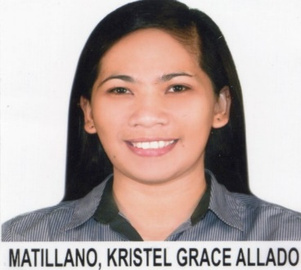
Kristel Grace Allado Matillano
Address: B11 L4 Suraya Homes. Subdivision, Cabantian, Davao City, Philippines
Email Address: Kristelgrace02@yahoo.com
Contact #: 09153539860

Personal Details:

Birth date: May 02, 1989
Birth place: General Santos City
Civil status: Single
Gender: Female
Citizenship: Filipino
Religion: Roman Catholic
Height: 5’
Weight: 45 kgs.

Education:

Degree: Registered Nurse (2010)
Board Exam Passer (November 2009)

Tertiary: San Pedro College (2005-2009)
12 C de Guzman Street, Davao City, Philippines

Secondary: Assumption College of Davao (2001-2005)
Juan P. Cabaguio Ave., Davao City, Philippines

Primary: Assumption College of Davao (1995- 2001)
Juan P. Cabaguio Ave., Davao City, Phillipines

Affiliations:

- Occupational Health Nurse (LTS Pinnacle Holdings) – May 2-15- January 2022
- Accredited Occupational Health Nurse Practitioner by Department of Labor and Employment (May 5, 2013- May 2021)
- Association of Safety Practitioners in the Philippines
- Occupational Health Nurses Association of the Philippines (OHNAP), Inc.

- Company Nurse (Allado Construction Company, Incorporated: ISO Accredited 9001: 2008; 14001:2004 Corr 1:2009; OHSAS 18001: 2007) – May 2009- April 10, 2015

- Safety Officer (Allado Construction Company, Incorporated)- May 2009- April 10, 2015

- Philippine Nurses Association, Incorporated – February 2010- present

Seminars Attended:

- Seminar on Managing Emerging Health Issues in the Workplace – June 26-27, 2013
- Managing IV complications – April 11, 2013
- Lecture on Total Parenteral Nutrition - February 16, 2013
- Annual Year End Convention: “Occupational Health Nurse, Towards Progress in Healthcare “-November 9- 10 2012
- Advance Air Seminar for Pollution Control Officer- October 30- 31, 2012
- 102nd Post Graduate Course on Basic Occupational Safety and Health (BOSH) for Nurses conducted by OHNAP Inc., - April 25- 30, 2011

- Pre- Service Training Program for Nurses (San Pedro Hospital)- April 4- May 8, 2011

- Effective Problem Solving and Decision Making conducted by TUV Rheinland, Philippines- February 24, 2011

- Health and Safety: Key to Work Excellence conducted by OHNAP Inc.- November 18-20, 2010

- Seminar on Environmental Management System (ISO 14001: 2004 + COR.1: 2009) Awareness Course conducted by TUV Rheinland, Philippines- September 30, 2010

- Basic Intravenous Therapy Training for Nurses- June 25- 27, 2010

- Construction Safety and Health Course for Site Safety Inspection- May 24- 28, 2010 conducted by CMDF, Davao City Philippines

- Seminar on Body Image and Facial Burns- January 21, 2010

