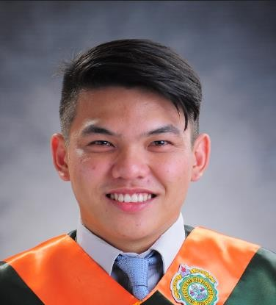
Christian Rey T. Ylaya
204 - D C. Padilla St. Mambaling Cebu City
: 09399158610 : ylayachristian23@gmail.com

CAREER OBJECTIVE:

To utilize my technical skills for achieving the target and developing the best performance in the organization, which offers key participation, team oriented tasks, immediate challenges, and career opportunity.

COMPETENCIES:

- Hard working and goal-oriented
- Exposed in AutoCAD 2D application
- Keen to details, organized and can multi task
- Can work with less supervision
- Communication skill (Verbal, Written)

SPECIAL SKILLS:
Electronics Hands on
Microsoft Office (Word, Excel, PowerPoint) AutoCAD
AutoCAD 3D
Electronic circuit Application designing (EWB, Fritzing, Multism, Proteus)
Google Earth Pro
House Wiring

WORK EXPERIENCE:
Wuhan Fiberhome International Technologies OSP Senior Design Engineer
November 2018 – August 2020
  - Joint staking Nap Location
  - Joint staking Poi Location
  - Site Survey (Pole tag, Pole size, Type of pole, Landmark, Distance pole to pole)
  - Final design of sites

Philippine Long Distance Telephone Company Inc. (PLDT)

Field Engineer

March 2021 – To Present
- Diagnose Fiber Lines
- Troubleshoot Fiber Lines
- Splicing Fiber Optic Cable
- Troubleshoot Modem

INTERNSHIP
Philippine Long Distance Telecommunication - South Cebu March 2017 - May 2017
  - Answer calls of Technician
  - Update tracker of Clarity
  - Install Cable from Node to Primary Frame for new install Vdsl Subscriber
  - Trace Expired Cable by Using Tracer

SEMINARS:
AM RECIEVER SEMINAR
University of San Jose - Recoletos October 29, 2016

DYLA RADIO STATION
University of San Jose - Recoletos February 05, 2018

FLUOR DANIELS COMPANY
University of San Jose - Recoletos December 18, 2018

DATCHE PHILIPPINES - CEBU
University of San Jose - Recoletos February 17, 2018

NATIONAL TELECOMMUNICATIONS COMMISSION
Mandaue City, Cebu January 09, 2018

EDUCATIONAL ATTAINMENT:

Vocational Department of Manpower Development and Placement
Electronic Product Servicing (TESDA)
Marijoy Building, D. Jakosalem Street, Cebu City April 23, to August 24, 2018

Tertiary University of San Jose – Recoletos
Bachelor of Science in Electronics and Communication Engineering Magallanes St., Cebu City
2013-2018

Secondary University of the Visayas
Colon St., Cebu City 2009-2013

Primary Saint Mary’s Academy
T. Abella St, San Nicolas, Cebu City, 2003-2009

ORGANIZATIONS AFFILIATED:

- INSTITUTE OF ELECTRONICS & COMMUNICATIONS ENGINEERS OF THE PHILIPPINES INC
Member 2013-2017

CHARACTER REFRENCES:

ENGR. JONATHAN ORACOY
ECE Professor
University of San Jose-Recoletos Magallanes St., Cebu City 09228571383

IAN JAY CANADA
SONA/FTTH Team leader
Wuhan Fiberhome International Technologies PAG-IBIG Bldg. Ayala Business Park, Cebu 09496173149

CHARLES JOHN RAMESO
OSP Senior Design Engineer
Wuhan Fiberhome International Technologies PAG-IBIG Bldg. Ayala Business Park, Cebu 09568178056

