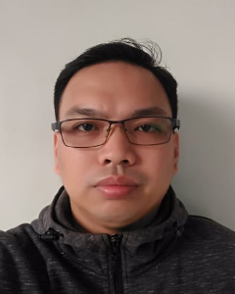

antonio regidor d. mangalindan
BUTCHER / DEBONER / TRIMMER

A skilled butcher with more than two years of experience, implementing new cutting techniques and ensuring high-quality products. My expertise has honed a craft in precision cutting and trimming meat. Strong communication skills and a customer-centric approach. I am a focused, highly motivated, and dependable individual who has the ability to oversee several projects at the same time; thus, can deliver a positive and successful end result.

EXPERIENCE:
Butcher
S&R Membership Shopping.
NUVALI Branch
May 21, 2023 - Present

Butcher Assistant / Apprentice
S&R Membership Shopping.
NUVALI Branch
November 2022 - May 2023

Butcher / meat Vendor
Belle's Meat Stall - Public Market
Munoz, Nueva Ecija
March 2021 to August 2022

SKILLS & DEVELOPMENTS:

BASIC COMPETENCIES
Participate in workplace communication
Work in a team environment
Solve/address general workplace problems
Develop career and life decisions
Contribute to workplace innovation
Present relevant information
Practice occupational health and safety procedures
Exercise efficient and effective sustainable practices in the workplace
Practice entrepreneurial skills in the workplace

COMMON COMPETENCIES
Apply food safety and sanitation
Use Standard measuring devices or instruments.
Perform mathematical computation
Implement good manufacturing practice procedure

CORE COMPETENCIES
Proficiency in Hog carcass breakdown
Proficiency in Hog primal deboning
Proficiency in Beef Fore quarter and Hind Breakdown
Proficiency in proper and safe use of slicer, meat grinder, bandsaw and tenderizer
Proficiency in retail cuts Proficiency in Packaging

EDUCATION:
Nueva Ecija Colleges
Bachelor of Science in Nursing 2002-2007

Training and seminars infinity Vocational Training School, Inc.
Introductory Hog Meat Cutting Program
October 2022

IVTSI and S&R 80-Day Meat Cutting Apprenticeship Program
March 2023

CONTACT:
4425-A Paciano Rizal Calamba City, Laguna Philippines 4027
Email add: armangalindan01@gmail.com
Tel no. 0943-706-1631 / 0976-150-3357

