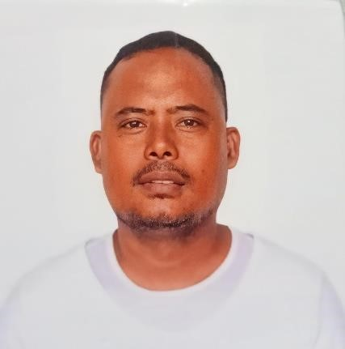
ADONIS S. ALMIROL (DRIVER)
Address: Canduman Housing, Mandaue City Cebu, Philippines
Contact # : 0965-3659893
Email Address : adonisalmirol4@gmail.com
Date of Birth: November 23, 1983

Age: 40
Language : Filipino and English
Hobbies/Interest : Driving, Online/video Games, watching movies.
License Code: 1,2,3,8
Passport Holder valid until 2/23/2032

SUMMARY
Driver with 10 years of experience transporting feed materials and Cargo throughout the provinces of the Visayas. Knowledgeable at following traffic regulations and safe driving techniques. possess a broad range of driving skills, as well as great customer service capabilities.
______________________________________________________________________________
WORK EXPERIENCE:
Trailer Truck Driver (2023- present)
A1 handler corporations ( liloan, Cebu)
- Deliver Cargo products such as animal feeds in the the cebu province.
- Deliver and communicate to the costumer and warehouse facilities.

Wheeler Truck Driver (2021 – 2023)
Transpecial Inc. ( Mandaue City , Cebu Philippines.)
- load and deliver nestle product to different parts of Visayas ( Bacolod City, Leyte and Cebu); and
- maintain the serviceability of the vehicle
- Deliver and Communicate to costumer’s store and warehouse

prime mover driver ( 2020-2021)
Roadlink Cargo Transport Services. (Lapu-Lapu City, Cebu, Philippines.)
- Deliver goods and products throughout the visayas provinces
- Load and Unload products
- Communicate professionally to the costumers
- Maintain a clean driving record

Trailer Truck Driver (2014-2019)
Skylark Company Inc. ( Road, Casuntingan, Mandaue City, Philippines.)
- Load and deliver feeds, flour and raw materials to make feeds like wheat, corn, etc. serving any branch of General Milling in Cebu Province.
- Checked all load-related documentation for completion and accuracy.
- Communicate consistently between warehouse and costumers
- Possess a broad knowledge of truck mechanics

________________________________________________________________________________
EDUCATIONAL DATA:

College: Siquijor State College
Address: Larena, Siquijor 2000 – 2004

Seondary: Siarre National High School 1996- 2000
Address: Siarre Sindangan, Zamboanga Del Norte

Elemetary: Palomoc Elementary School 1990-1996
Address: Palomoc, Titay, Zamboanga Sibugay

________________________________________________________________________________
CERTIFICATES AND TRAININGS
Defensive Driving Course through virtual Methodology Training (2020)
Driver Academy Training (September 25, 2019) Certificate of employment

________________________________________________________________________________
REFERENCE:

Ms. Kristi Ninya Ompad Branch Coordinator – Transpecial Inc. Address: Mandaue City, Cebu CP# 09092205156

