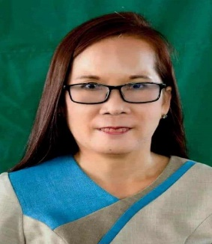
NORMA V. TOQUERO
SABUANAN STA. LUCIA,
ILOCOS SUR, PHILIPPINES 2712
norma,aviladeped.gov.ph

OBJECTIVE
A highly motivated, organized, and dedicated individual/ team player/ with excellent curriculum design, interpersonal and communication skills seeking an Early Childhood Education.

- Experience working with children/Kindergarten Learners
- Strong problem-solving skills, with the ability to make professional judgement.
- Solid ability to establish credibility and excellent relationship with other.
- Ability to multitask and work in a fast placed environment.
- Extremely efficient and organized under pressure.
- Speak English

EDUCATION

- Finished 36 units in Master of Arts in Special Education Year 2013-2016
Don Mariano Marcos State University La Union College

- Finished 9 units In Master of Arts in Special Education Year 2021-2022
Graduated Early Childhood Education

- Graduated of Bachelor of Arts/Bachelor of Elementary Education Year 1989- 1993
Union Christian College/University Of Norther Philippines Year 1993/1996

- Passed the Licensure Examination for Teacher Year 1996

EXPERIENCE

- Teaching in Elementary (Primary School) Year 2015 at Present
Sabuanan Elementary School SPED Center

- Special Education Teacher for Different Disability Year 2017-2018
Sabuanan Elementary School SPED Center

- Kindergaten Teacher Year 2015-2017
Voluntary Teacher of Kindergarten Teacher Year 2010-2015
Sabuanan Elementary School SPED Center

- Care Assistant Year 2007-2010
Lorne Bank Care Homes,
Hamilton Scotland

- Domestic Helper September-December 2010
Rome, Italy

- Machine Operator Year 1999-2002
MaxEdge Company, T
Taiwan

INTERESTS/ACTIVITIES
- Cooking
- Driving
- Teaching
- Farming

COMPUTER SKILLS
- Proficient in Microsoft Word, Excel and PowerPoint and Internet

