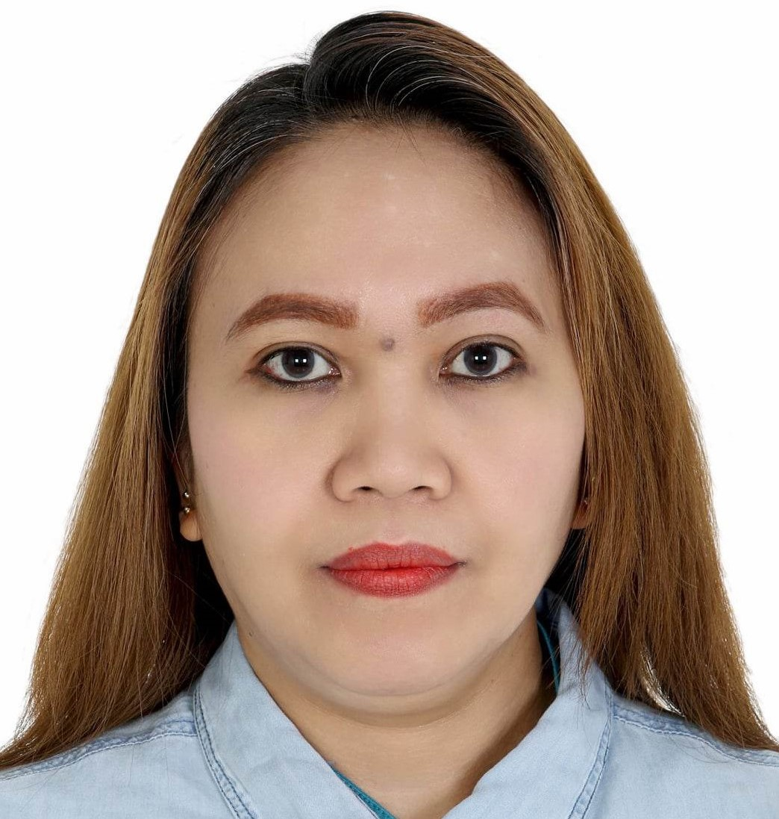
Catherine Quijano Abergas, RN
Blk.03 Lot 16 No.042 Starbross St. Davao Farm
Vill. Subd. Brgy Lapu-lapu Agdao, Davao City, Philippines
Mobile number: +966542667351
E-mail Address: abergascatherine39@gmail.com

Basic Function:
- Responsible for providing comprehensive nursing care utilizing the nursing process and meeting the established standard of nursing practice and performance.
- Responsible for providing comprehensive nursing care in the clinics or the emergency department.
- Provide patient care as assigned according to the established policies and evidence-based practice.
- Documents all relevant information correctly, appropriately and in a timely manner.
- Ensuring the clinic is ready for effective use by the physician (from consumable material stock level and medical equipment standpoint).

EXPERIENCE:
- May 27, 2017- up to present at Al Yarmouk Medical Polyclinic as a Nurse.
Job Description:
- Comply with all policies, procedures, clinical protocols, standards and guidelines based in legislation and evidence- based nursing practice.
- Reports equipment failures, safety and security issues and or reduction of supply inventory to the nurse supervisor.
- Acts as an advocate for patients and families.
- To cooperate and work effectively with other professionals in the multi- disciplinary team to ensure continuity of care.
- Complies with policies for personal and patient safety and for the prevention of healthcare associated infections.
- Promotes a safe environment and safe patient care by embracing a safety culture.
- Contributes to the achievement of clinical quality outcome indication and patient satisfaction.
- Participates in self- education, training and development, as applicable.
- Contributes to the achievement of cost efficiency savings on units.
- Maintains as awareness of resource utilization, exercising care in the ordering and use of staff, equipment and materials.
- Completes the nursing assessment and documents medical history from a patient.
- Adhere to the Medicines Management for the safekeeping and administration of medication.
- March 24, 2016- December 31, 2016 in Mansel Construction Supply as a Home Base Care, Clinic, Hospital and Dialysis Unit.
- August 11, 2015 up to February 15, 2016 in Professional Nurse Specialist, Inc. as a Private Duty Nurse.

Job Description:
  - Contracts independently to render nursing care, usually to one patient, in hospital or private home: Administers medications, treatments, dressings, and other nursing services, according to physician's instructions and condition of patient.
  - Observes, evaluates, and records symptoms.
  - Applies independent emergency measures to counteract adverse developments and notifies physician of patient's condition.
  - Directs patient in good health habits.
  - Gives information to family in treatment of patient and maintenance of healthful environment.
  - Maintains equipment and supplies.
  - Cooperates with community agencies furnishing assistance to patient.
  - May supervise diet when employed in private home.
  - May specialize in one field of nursing, such as obstetrics, paediatrics or dental.

- February 7, 2010 to April 12, 2013 then June 22, 2013 up to February 7, 2014 in International Medical Clinics at Dammam K. S. A. as a General Nurse assigned at EENT, Paediatric, Dental, GP, Internist Clinics and Laboratory.
Job description:
    - Admit patient and take their vital signs.
    - Assist the doctor in physical examination and emergency.
    - Perform and explain the aim and purpose of each procedure to the patient as ordered by the doctor such as injection, emergency medication and oxygen administration etc.
    - Perform and maintain statistical record of the patient going in and out in the record book with their respected treatment.
    - Collect samples such as blood, urine, stool and others for laboratory investigation as needed.
    - Proper endorsement to other nurse for the treatment given to the patient.
    - Demonstrates positive attitude towards job assignment in general and job assignment particularly in the assigned unit and other units when needed (as in floating or rotations).
    - Extends a helping hand (to do an extra mile) as needed.
    - Performs other related duties as assigned and requested.
    - Assigned in extraction area as phlebotomist. Also assigned in any recording for documents in laboratory.
    - Assigned in storeroom and stocks medicines for recording monthly inventory.
    - Assigned also in the documentations for immigration going to Canada, Australia and New Zealand.

- April 13, 2013 up to June 21, 2013 in International Medical Clinics at Dammam K.S.A as a Head Nurse.
Job description:

- Supervises and coordinates nursing activities in hospital unit: Assigns duties and coordinates nursing service.
- Evaluates nursing activities to ensure patient care, staff relations, and efficiency of service.
- Observes nursing care and visits patients to ensure that nursing care is carried out as directed, and treatment administered in accordance with physician's instructions.
- Directs preparation and maintenance of patients' clinical records.
- Inspects rooms and clinics for cleanliness and comfort.
- Accompanies physician on rounds, and keeps informed of special orders concerning patients.
- Participates in orientation and training of personnel.
- 8Orders, or directs ordering of drugs, solutions, and equipment, and maintains records on narcotics.
- 9. Investigates and resolves complaints, or refers unusual problems to superior.
Special Area Assigned:
- Out- Patient Department
- Emergency Room
- OB and OB-gyne ward
- Male and Female Surgical ward
- EENT ward
- Pediatric ward
- General medicine ward
- GP, EENT, Pediatric and Dental Clinics
- Laboratory

Equipment Handled:
- BP Apparatus - Glucometer
- Suction Apparatus - Syringe Pump
- ECG Machine - Thermoscan
- Built-in Oxygen - Catheter
- Nebulizer - Thermometer
- Pulse Oxymeter - Weighing Scale
- Othoscope - Defibrillator
- Ambu Bag - NGT for feeding
- Enema Can
- Any dressing and minor surgery equipment.

SKILLS:
- Taking vital signs, weighing and injection (IM, Skin test and subcutaneous).
- Insertion of Foley catheter and IV line.
- Doing bedside ECG, pulse oximeter, enemas. NGT feeding.
- Doing dressing, and removal of stitches.
- Doing bed making like (open, closed, post-op and OB and Ob-gyne and any type of bed making)
- Doing oxygenation and nebulization.
- Doing Glucometer for Glucose test.
- Give medication through NGT feeding, IV fluids, IVTT and orals.
- Do bedside care to the patient whenever possible.
- Do sitz bath, sponge bath and hot and cold compress as needed.
- Can do blood extraction for laboratory samples.
- Monitoring the intake and output.
- Suction of tracheostomy tube and through mouth and nose as ordered.
- Assist in endotracheal Insertion.
- Assist catherization.
- Assist in enemas and NGT feeding and NGT insertion.
- Assist minor surgeries done in ER and dressing room.

GOVERNMENT EXAMINATION TAKEN:

Passed Philippine Nurse Licensure Examination: June 09, 2023
Registration Date: June 06,2024.

Passed the Licensure Examination for Nurse Health Care Assistant given by the Saudi Commission for Health Specialties: License No. 10-K-N-0346503. Last September 2010.

EDUCATION:
1987-1993 Primary School: Assumption School of Davao.
1993-1997 Secondary School: Assumption School of Davao.

1997-2003 College: Mindanao Medical Foundation College
Course: Bachelor of Science in Nursing.
Languages
* Effective Communication (English, Arabic, Bisaya and Tagalog).

SEMINARS/ TRAININGS ATTENDED:
- Basic Life Support (CPR and AED) Program
Issued Date: January 31, 2023 SBAIHC International Training Center
By: DR. Mohammad Al Faigh Hospital
Riyadh Saudi Arabia

- Health Quality and Leadership Training. Consulting. Research
Clinical Documentation Imprpvement (CDI)
Issued Date: August 19, 2023
By: Dr Ahmed Bahloul
CEO- Founder

REFERENCE:
Mrs. Mary Joy Aliwalas, SCRN, RN Labo District Hospital
Nurse +639665737889

Mrs. Michele Nicandro SCRN, RN Armed Forces Hospital
Nurse +966531496371

Mrs. Jan- Deliza Bokingo, SCRN, RN Quebec Canada
Nurse +14382330317

PERSONAL DATA

Name : Catherine Quijano Abergas

Nickname : Cathy

Age : 44 yrs. old

Sex : Female

Birth date : August 08, 1979

Civil Status : Married

Citizenship : Filipino

Place of Birth : Davao City

Height : 5’2 1/2ft and 156cms

Weight : 53-54 kls

Religion : Roman Catholic

FAMILY

Father : Lucilo S. Quijano
Retired Accountant

Mother : Carolina C. Quijano
Retired Teacher

