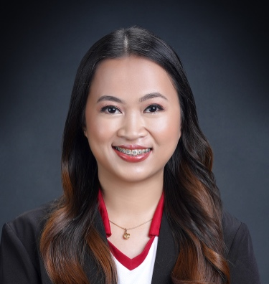
GFH
MAY FLOR CASITA
Manila, Philippines
mayflorcasita@gmail.com
+639059051838

EDUCATIONAL BACKGROUND

COLLEGE PHILIPPINE NORMAL UNIVERSITY
Bachelor of Secondary Education Major in English
Graduated in 2016

HIGH SCHOOL SANTA ROSA SCIENCE AND TECHNOLOGY HIGH SCHOOL
Graduated in 2012

ELIGIBILITY AND WORK EXPERIENCE

LICENSED SECONDARY EDUCATION TEACHER
Professional Regulation Commission, Philippines

ENGLISH TEACHER (2016-present)
Colegio San Agustin - Makati, Philippines (Private Catholic School)
- Taught Literature (Afro-Asian, English-American and World Literature) and Language Arts
- Handled students with special needs like ADHD, ADD, dyslexia in mainstream classes

LEARNING MANAGEMENT SYSTEM COORDINATOR – ARALINKS (2021-2022)
Colegio San Agustin - Makati, Philippines
- Organized training and workshops for teachers

HOMEROOM ADVISER (2019-present)
Colegio San Agustin - Makati, Philippines
- Homeroom Adviser, Grade 9 Section H (2019-2020), Section B – Pull-out Class (2020-2021), Grade 8 Section B – Pull-out Class (2021-2022), and Grade 10 Section B – Pull-out Class (2022-present)

CLUB MODERATOR (2018-2022)
Colegio San Agustin - Makati, Philippines
- Moderator, Worsdmith (2018-2022)

ESL TUTOR (2020-2022)
51talk
- Taught ESL to Chinese students from zero English to English for specific purposes

FREELANCE TUTOR (2021-2023)
Chungdahm Philippines, Inc.
- Proofread essays and speech of students

ENGLISH TUTOR (2021-2022)
Brainlight Learning Center
- Taught English literature and language to elementary and high school students

AFFILIATIONS
- British Council Philippines, Member (2017 – 2019)
- International Literacy Association, Member (present)

SEMINARS/ TRAININGS

- Professional Leaning Communities That Transform a School’s Teaching and Learning Culture
- Resilience in the Workplace
- Connecting with Students: A Seminar on Facilitating and Helping Skills
- Module Writing Seminar
- One Size Fits Few: The Call for Constructivism in Today’s Classroom
- Empowering the 21st Century Learner
- Tried and Tested Strategies That Form Students’ Character: Empathy, Resilience, and Grit
- Reading Association of the Philippines National Demofest- Multiple Literacies
- A Practical Guide to Developing Effective Distance Learning Resources
- Innovate, Inspire, Ignite, Integrating Values in Online Distance Learning
- Digital Ethics: Responsible Social Media Practices for Educators
- Using Google Suites and Apps for Education
- Education Law in the Time of Covid-19 Pandemic
- Developing Optimism Towards Mental Well-Being Amidst Difficult Situations
- Growth Mindset, Motivation, and Language Attitude for Successful Language Learning

SPECIAL SKILLS

Communication Skills
- Fluent in English
- Good written and verbal skills
Technical Skills
- Proficient in Microsoft Word, PowerPoint, and Excel, and other technical tools and apps for teaching
Planning Skills
- Can prepare lesson plans for effective teaching
- Can design assessment and evaluation materials
Creative Skills
- Can utilize creative and innovative teaching methods for better grasp of concepts
- Can create learning modules and instructional materials
Management Skills
- Can organize various events
- Can administer activities for students and teachers
- Can train teachers and students
Research Skills
- Can collect large amount of data for research papers
- Can critique others’ work constructively

CHARACTER REFERENCES

Ms. Katrina Paco Ms. Camille Limon Ms. Kathryn Vergara
+639653299793 +639610119186 240 344 9962
pacokatrina@gmail.com c.limon@csa.edu.ph kvergara@goretti.org
Alpha Angelicum Academy, Biñan, Laguna Colegio San Agustin-Makati St. Maria Goretti Catholic High School

