Human Resource Department

Dear Sir/ Madam,

I would to apply for a part time position that fits my credentials as a professional. As requested, I am enclosing a completed resume and references.

The opportunity presented in this listing is very interesting, and I believe that my strong technical experience and education will make me a very competitive candidate for the position.

The key strengths that I possess for success in this position include:
- I have successfully designed, developed, and supported live use applications.
- I strived for continued excellence
- Provide exceptional contributions to the institution

With a BS degree in Psychology, Education Psychology, and some units in Graduate school, I have a full understanding of the full life application of interpersonal relation with other. I am also a Licensed Professional Teacher recognized by the Professional Regulatory Commission.

Please see my resume for additional information on my experience.

I can be reached anytime via mobile 0966 007 33 70 or through my mail, mjatuel@gmail.com

Thank you for your time and consideration.

I look forward to speaking with you about this employment opportunity.

Respectfully yours,
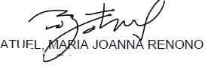

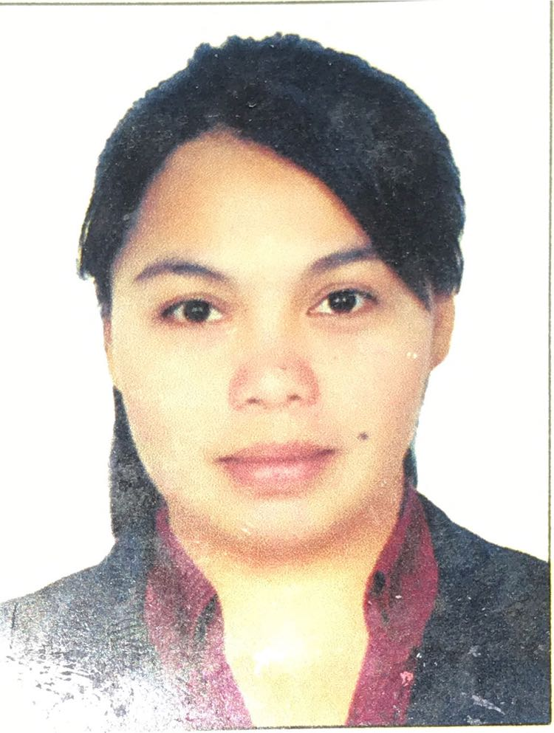
Maria Joanna R. Atuel L.P.T
mjatuel@gmail.com
+639660073370
Objectives: To seek a career development and opportunity
Qualification Summary:
- Highly organized, ability to work in a fast paced environment.
- 17 years’ work includes experience in Administrative, Customer Service and Education industry.
- Fast learner, easy adaptation on new and complex software applications.
- I have successfully designed, developed, and supported live use applications.
- I strived for continued excellence
Education: Graduate School – Master of Arts in Education major in Guidance and Counselling (on going)
DE LA SALLE UNIVERSITY- Dasmariñas
Post Baccalaureate –Diploma in Teaching Physical Education and Health (July 2021)
Bachelor’s Degree – BS Psychology – Educational Psychology (March 2005)
Includes complete Education Units.
PHILIPPINE NORMAL UNIVERSITY- Manila

Working Experiences:
Education:

FRANCISCO E BARZAGA INTEGRATED HIGH SCHOOL – August 2019- Present
DepEd Division City of Dasmarinas
Teacher, JHS and SHS

BLESSED MARY ACADEMY
City of Dasmariñas Cavite, Philippines
Faculty (Grades 5 and 6, Junior High School and Senior High School) – November 2017-March 2019
- Full time faculty
- Science for Grades 5 and 6
- Christian Living and Values Education for Junior High School(Grades 7 to 10)
- Personal Development, Practical Research and Discipline and Ideas in Applied Social Science for Senior High School (grades 11 and 12)

ST. JOSEPH’S COLLEGE OF QUEZON CITY
Quezon City, Philippines
Faculty (Kinder-Grade School Department) – June 2012 – March 2013
- Communication and Information Technology Teacher for Grades 1-6 (includes software and hardware, Applications of Information Technology)
- Arts teacher for Grade 2
- All subjects taught are integrated to Special Education

CASA REAL MONTESSORI Inc.
Park Place Imus, Cavite, Philippines
Guidance Counsellor/ Teacher – September 2008 – March 2011
- Counsellor for Grade school students from 1-6
- Administer a Psychological test for assessments (standardized)
- Administrative work
- Student Affairs
- Social Studies and Arts Teacher for Grades 1-3

ST. MARY MAGDALENE SHOOL
Kawit, Cavite, Philippines
Part Time Teacher – Dec 2011 – March 2015
- Music, arts and Physical Education Teacher for Grades 4-6

Other Work Experiences:

PRETTYCLOSE GLOBAL SERVICES
G.T Towers International Makati City Philippines
Hotel Brand Specialist – January 2017 to July 2017(Contractual)
• Focuses on a holistic approach to an overall brand
• Focus on certain target segments
• Research, design and strategy are key in the work
BELL CANADA
Iqor Philippines Dasmariñas City Cavite Philippines
Collection Specialist – April 2016 – December 2016
- Deals with Accounts receivable
- Deals with high concerned issues on customer such as discrepancies and other billing issues

FIRSTSOURCE LIMITED (Barclaycard UK Commercial Accounts)
NORTHGATE FILINVEST, ALABANG, MUNTINLUPA CITY
Telephony Financial Adviser – December 2015 – March 2016
- Manage the finance flow of credit cards processed payments etc.
- Assisting cardholders via phone calls
- Deals with Business Accounts
FIRSTSOURCE LIMITED (Barclays Bank U.S Accounts)
NORTHGATE FILINVEST, ALABANG, MUNTINLUPA CITY
Relationship Manager - October 2014 to November 2015
- Manage the finance flow of credit cards processed payments etc.
- Assisting cardholders via phone calls
- Deals with Personal Credit Cards
LUVENUS
SINGAPORE CHANGI AIRPORT, Singapore
Customer Care Manager – August 2013 – August 2014
EP G5469859W
- Professional Jeweler
- Estimates whole sale and retail value of gold, following price guides and market fluctuations
- Provides recommendation to the customer that suits their budget and design
- Arranges jewelry pieces into specific design
- Ensure smooth product and service deliveries
- Perform and provide advice on product usage and demonstration
- Conduct initial assessment and computation to clients
FERE ST. BENILDE ROMANCION EDUCATIONAL FOUNDATION Inc.
(De La Salle University) Dasmarinas, Cavite, Philippines
Student Publications Office (Secretary) July 2007 – October 2007
Mathematics Department (Secretary) November 2007 – June 2008
- Updating of Department Files
- Arrange the schedules of the Chair such as meetings, appointment and other Institution relations
- Maintaining Archives
- Assists in financial decisions and routine administrative work
- Project coordination and correspondence
GMA RURAL BANK OF CAVITE Inc.
Imus, Cavite, Philippines
Treasury Associate (November 2006 – June 2007)
Clearing Associate (September 2006 – October 2006)
Teller (January 2006 – August 2006)

- (TRY) manages fund requirements of bank, interest rate settings, and cash managements.
- (CLR) in charge with inward check circulated in the clearing house through our conduit banks.
- Responsible for any over the counter transactions

